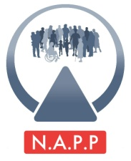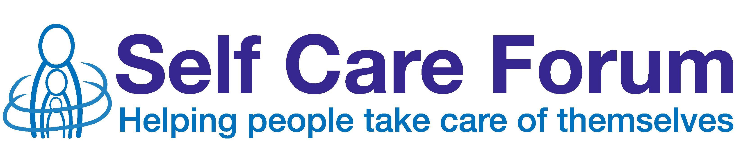

Mission impossible:
Self care for life – Growing older healthily

Hosted by the Self Care Forum, PAGB
8th November, 2012
Institute of Physics, 76 Portland Place, London,

Statement from Stephanie Varah, Chief Executive, National Association for Patient Participation (N.A.P.P) – national patients champion, Self Care Forum

For the Motion:

Modern medicine has infantilised us and we can no longer self care

I am speaking today for the motion although I find this a challenge to my natural optimism and knowledge about the extent to which patients are already engaged in the self care agenda. I also know as a realist, from my career in patient and public involvement, that the motion is to some degree an accurate reflection of the current health system culture.

N.A.P.P, the national patients champion for the Self Care Forum, firmly believes that the most effective way for self care to become the first approach we [as patients] adopt in dealing with minor illnesses and ailments is through empowerment, by working in partnership with health professionals and through relationships built on mutual respect.

From experience and feedback from Patient Participation Groups we work with, some PPG representatives are with us today, we know that a growing number of patients are becoming more confident in making self care decisions through having access to information and the support of other patients from groups at their surgery.

An increasing number of GPs are recognising the added value to their service and their practice population of having an informed group of patients to work with in active partnership. [Contrary to the Motion].There is still a very long way to go however before the majority of the population has a ‘self care first’ mind-set and active patient groups are the norm. Why is this so?

I am not comfortable with the term ‘infantilised’ but there is no simple way to describe the dynamics and complexities that influence the way patients behave and their expectations of the NHS. It was suggested to me that in speaking for the motion I might want to emphasise that the healthcare professional/patient relationship is paternalistic and unequal – I don’t believe it is that ‘black and white’ but there most certainly needs to be a greater shift by those providing services towards accepting, acknowledging and encouraging those who use services as ‘co-producers’ of better health outcomes.

I believe it is the health system as a whole that has militated against self care rather than the profession of medicine.

The health system is widely available to all, free at the point of use – people do not have to pay for a professional opinion and default to using the service without thinking more deeply about how it is made available, what impact their demands have upon the service and other users. People feel they have a right to a service as tax payers.

There is a universal deference to seeking professional advice (that is freely available) rather than making decisions for oneself.

People often feel the system is not listening to them – so why should patients bother taking more of an active interest when users’ perspectives appear to be undervalued? This perception is often reinforced by some professional attitudes.

It is necessary that some relationships between professionals and patients are unequal – as patients we consult a specialist with particular knowledge and skills however relationships and interactions between healthcare professionals and patients generally need to be built on mutual respect so that mature dialogue and decision making is the norm.

For self care to flourish we need:

- Greater empowerment and understanding for patients through information and support
- Professional recognition of the value of patients perspectives and experiential knowledge
- Patient/professional relationships built on mutual respect

I contest that these factors combine to reinforce behaviours which mean that ‘self care first’ is not our primary predisposition and move to support the motion.

