Your Logo
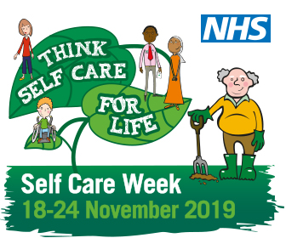
Think Self Care for Life: Think the Pharmacist for expert health advice
It’s Self Care Week 2019 (18 – 24 November) and [organisation name] wants to remind you of the health expert on the High Street – the community pharmacist.
Pharmacists are highly trained health professionals who give advice and recommend treatments for self treatable conditions such as coughs, colds, sprains and strains.
[Local pharmacist / GP] “People go to the doctor with common ailments because they are unsure how long symptoms last and need reassurance that it isn’t anything more serious. Instead of waiting for an appointment at your surgery, consider going to your local pharmacist first.
“Pharmacists will help you choose the right treatment for your ailment and can explain the normal duration of symptoms. They can also offer you help to stop smoking, manage your weight, and can often provide flu jabs and blood pressure checks. Many pharmacies also have private consulting rooms.
“If you have a cold or flu virus it is worth remembering that antibiotics won’t help. In fact, taking them can reduce their effectiveness when they’re needed for ailments they can help with.’’
If you have a long term condition and are worried how common ailments may be affecting you, or if you want advice on managing your medicines, visit your pharmacist first.
Save yourself the time and bother of booking a GP appointment or visiting A&E. Think the pharmacist. Think self care for life.
Self Care Week is 18 – 24 November, why not join us [add information here about your Self Care Week programme of activities].
- ENDS -
Notes to editors:
- Self Care Week takes place 18-24 November 2019 and has the theme “Think Self Care for Life”.
- Self Care Week is an annual national initiative organised by the Self Care Forum to raise awareness about the benefits of self care and what people can do to take care of their health. It is to promote and encourage more self care across communities, families and generations.
- Information Resources:
http://www.selfcareforum.org/fact-sheets/ (Self Care Forum fact sheets)
https://www.nhs.uk/ (NHS website)
http://antibioticguardian.com/ (Antibiotics Guardian)
4. Internal contact details for journalists

