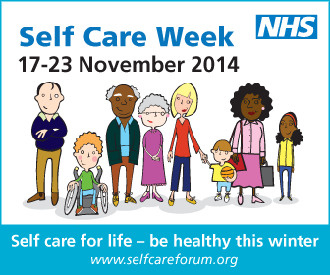
Your logo
Sample Press Release 1 / News Article / Website Text
Don’t be left out in the cold, understand how to look after your winter ailments
During Self Care Week [input your organisation name] want to support you to self care for life and understand how to take better care of yourself and your family members, especially during the winter months, when seasonal illnesses increase.
Preventing ill health is important during winter and so choose lifestyle options that will impact positively on your physical health, mental wellbeing and self esteem. To beat those winter blues and keep healthy make sure you eat well, drink in moderation, stop smoking and stay active.
It is usual for adults to have two to four colds a year while children are likely to have three to eight as their immune system is more susceptible to viral infections. If you do catch a winter ailment such as a cough, cold or sore throat, treat yourself better by keeping warm and drinking plenty of fluids. Over the counter medicines can help with symptom relief and a pharmacist can offer advice if you need it.
As well as pharmacy support, NHS Choices and the Self Care Forum can provide helpful information on common winter ailments such as coughs, colds, sore throats and fever in children. Generally, symptoms last longer than you might think and it is helpful to know what is normal and what isn’t, Self Care Forum fact sheets can help with this. It is worth remembering also that antibiotics don’t work on most winter illnesses like colds and flu as these are viral infections.
If you have a long term condition, prepare for winter by ensuring you don’t run out of your medication, many pharmacists offer repeat prescription services without the need to see your GP.
Before you visit A&E, remember what it’s there for. It provides vital care for life threatening emergencies, such as loss of consciousness, suspected heart attacks, breathing difficulties, or severe bleeding that cannot be stopped. If you have a winter ailment, ask yourself, do I want to spend 4 hours waiting for someone to look at my sore throat?
Be healthy this winter.
A number of local activities are being held during Self Care Week to raise awareness about looking after your health, why not join us [provide details of your local activities] and stay healthy this winter.
Notes to editors:
- Self Care Week takes place 17-23 November 2014 and has the theme “Self care for life – be healthy this winter.”
- Self Care Week is a yearly campaign to raise awareness about the benefits of self care and what people can do to take care of their own health at home. The point of the campaign is to promote and encourage more self care across communities, families and generations.
- Information Resources:
http://www.selfcareforum.org/fact-sheets/ (Self Care Forum fact sheets)
http://www.treatyourselfbetter.co.uk/ (Treat Yourself Better website)
http://www.nhs.uk/Planners/Yourhealth/Pages/self-care-week-2014.aspx (NHS Choices)
http://antibioticguardian.com/ (Antibiotics Guardian)
http://www.rcgp.org.uk/clinical-and-research/target-antibiotics-toolkit/patient-information-leaflets.aspx (Antibiotics Awareness)
4. Internal contact details for journalists

