

Self Care Week Tweets for 18 – 24 November 2019
Long Term Conditions
(To “save as picture” right click on images).
Day | Tweet | Image
Monday | It’s #selfcareweek and we want to remind you to take care of your physical health and mental wellbeing, particularly if you have a long term condition. Think #seflcareforlife. @SelfCareForum | 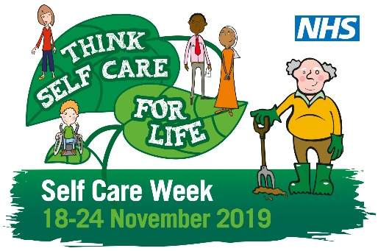
Tuesday | It’s #selfcareweek. Think #selfcareforlife. Winter viruses are really irritating especially if you have a long term condition. Your pharmacist can help with advice on stocking up your medicine cabinet. Fact sheets are also available from @SelfCareForum.  http://bit.ly/2tiBs9K | 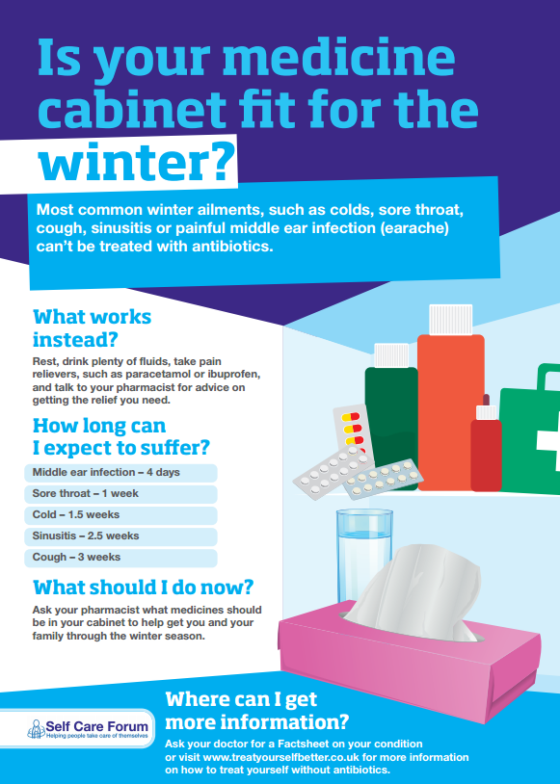
Wednesday | Think #selfcareforlife during #selfcareweek and always. If you have a long term condition exercise can often help you manage. This free app will plot a 12 week plan tailored to you. http://bit.ly/32uF9Ji  @SelfCareForum | 
Thursday | It’s #selfcareweek. If you have a long-term condition, you will spend approx. 6 hours a year with a health professional and the remaining 8,754 hours your health yourself. You might find this app helpful. http://bit.ly/36HGH6l @SelfCareForum #selfcareforlife
Friday | Don’t feel isolated if you are newly diagnosed with a long term condition. Support is available – your GP can help with a care plan. Self care is not no care! #selfcareweek @SelfCareForum | 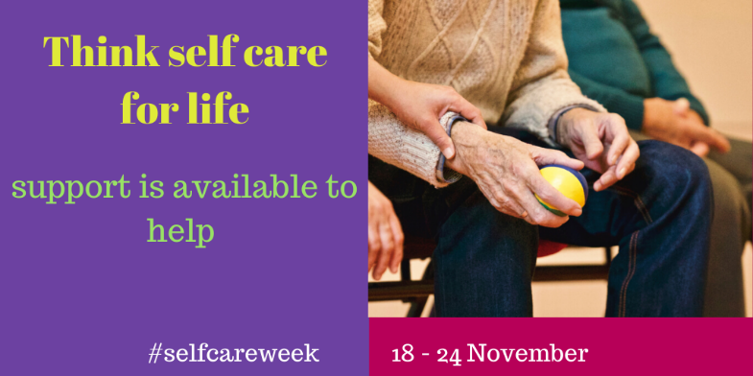
Saturday | It’s #selfcareweek - if you have a long term condition you might need your blood pressure checked, visit your pharmacy and get it checked without the need for an appointment. #selfcareforlife  @SelfCareForum | 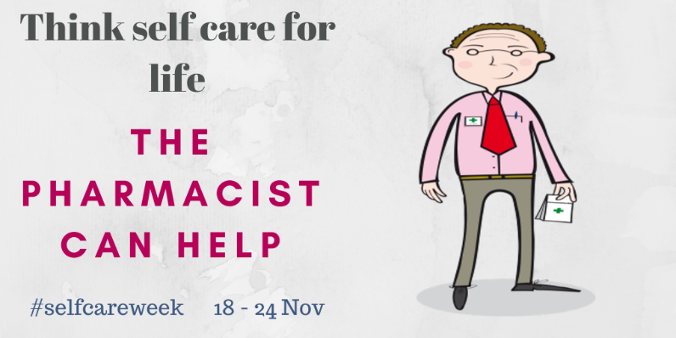
Sunday | A long term condition can be disabling and frustrating for many to manage. It’s #selfcareweek - don’t be afraid to ask your GP, nurse or pharmacist for help. #selfcare is NOT no care. This leaflet might help.  http://bit.ly/34GB7yZ @SelfCareForum | 