

Self Care Week Tweets for 18 – 24 November 2019
Minor Conditions
(To “save as picture” right click on images).
Day | Tweet | Image
Monday | It’s #selfcareweek – remember if you have a common ailment, it’s quicker and easier to think #selfcareforlife. The pharmacist can help with advice or why not look at these fact sheets from @SelfCareForum. http://bit.ly/2tiBs9K | 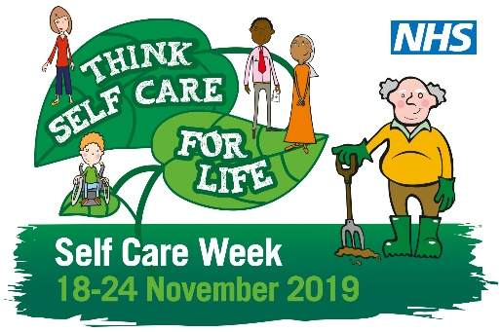
Tuesday | It’s #selfcareweek – so why not prepare for irritating winter viruses by stocking up your medicine cabinet? These fact sheets on common ailments can also help @SelfCareForum.  http://bit.ly/2tiBs9K. Think #selfcareforlife | 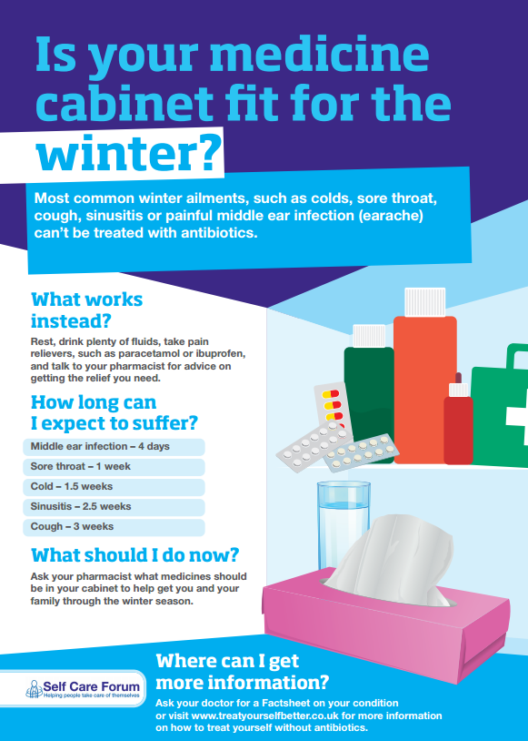
Wednesday | It’s #selfcareweek. This #selfcareforlife. About 80 per cent of people suffer from back pain at some point in their life. Know the facts about backpain with this factsheet from. @SelfCareForum http://bit.ly/2tiBs9K | 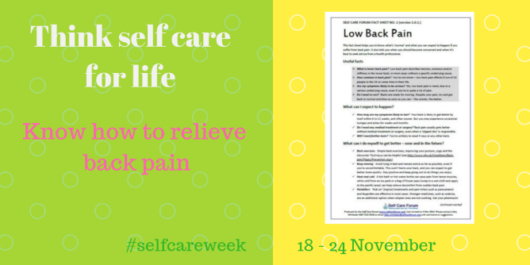
Thursday | It’s #selfcareweek. Mild feverish illness is a normal part of childhood and generally a harmless response to help the body fight infection. Know the facts with this factsheet from @SelfCareForum. http://bit.ly/2NsT3HP | 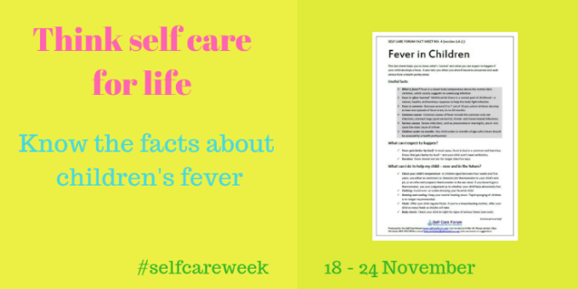
Friday | It’s difficult in the winter to get enough vit d. It’s advisable to take a supplement, especially if you are pregnant, young or have darker skin. For more info read this factsheet by the @SelfCareForum.#selfcareweek #selfcareforlife http://bit.ly/2J4L6oo | 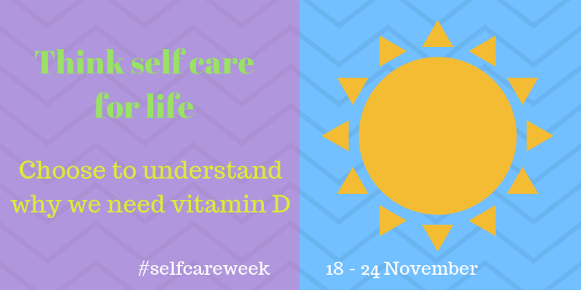
Saturday | Antibiotics don’t help with viruses such as sore throats, coughs or colds. The pharmacist can help with advice on symptom relief. Think #selfcareforlife during #selfcareweek and always. @SelfCareForum | 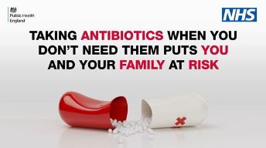
Sunday | There are between 1m – 1.5m A&E visits each year for ankle sprains, most commonly from sports injuries. Know the facts about sprains and strains with this fact sheet from @SelfCareForum #selfcareweek #selfcareforlife http://bit.ly/2NsT3HP | 