

Self Care Week Tweets for 18 – 24 November 2019
Minor Conditions
(To “save as picture” right click on images).
Pharmacy Related Self Care Week Tweets for 2019

Day | Tweet | Image
Monday | It’s #selfcareweek – remember community pharmacies deliver accessible health care in the community so people can take care of their health and #seflcareforlife. @SelfCareForum | 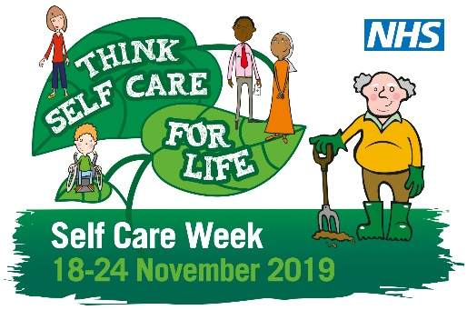
Tuesday | Coming up to winter you might need help with irritating winter viruses such as coughs, sore throats and colds. No need to visit your GP, speak to your pharmacist for quick accessible help. http://bit.ly/2tiBs9K #selfcareweek #selfcareforlife @SelfCareForum | 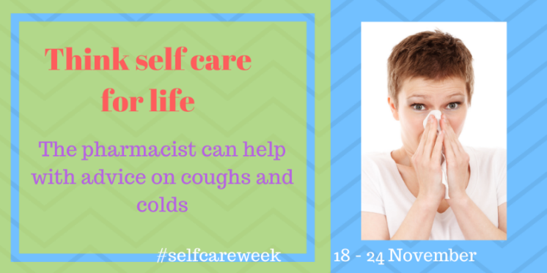
Wednesday | Community pharmacists are health experts on the high street and #selfcareweek reminds us to #choosewell by visiting the pharmacist for health advice. @SelfCareForum #selfcareforlife | 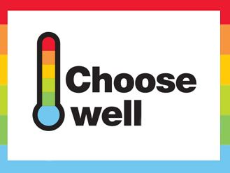
Thursday | It’s #selfcareweek – think #selfcareforlife and make positive changes to your lifestyle. Pharmacists can help with advice on wellbeing such as smoking, weight and nutrition. @SelfCareForum | 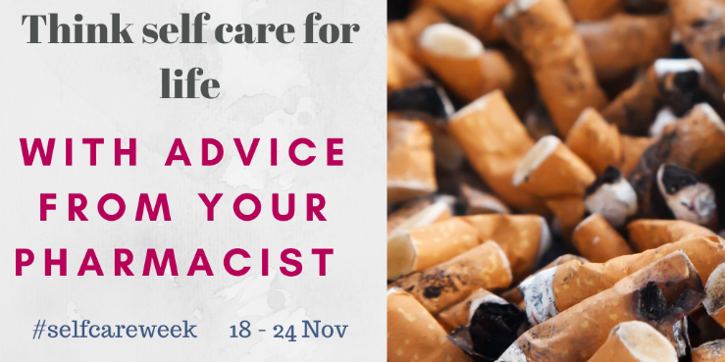
Friday | If you have a long term condition, you might need advice on how common ailments can affect you. The pharmacist can help. #selfcareweek #selfcareforlife @SelfCareForum | 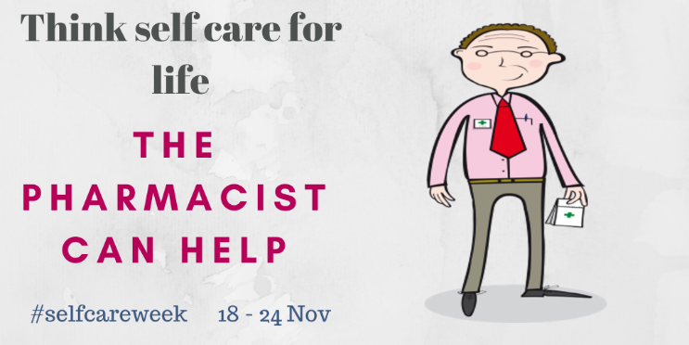
Saturday | Antibiotics don’t help with viruses such as sore throat and cough – get advice from the pharmacist. Think #selfcareforlife during #selfcareweek and always. @SelfCareForum | 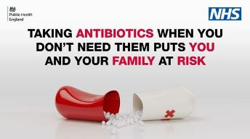
Sunday | It’s #selfcareweek – have you thought about getting a flu jab? The pharmacist can help. #selfcareforlife @SelfCareForum

