

Self Care Week Tweets for 18 – 24 November 2019
Wellbeing
(To “save as picture” right click on images).
Day | Tweet | Image
Monday | It’s #selfcareweek and we want to remind you to take care of your physical health and mental wellbeing. Think #selfcareforlife always. @SelfCareForum | 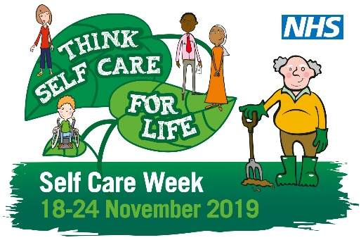
Tuesday | Getting out into the fresh air for a walk, a run or a play does wonders for our physical health and our mental wellbeing. Make time every day to get some fresh air. @SelfCareForum.  #selfcareweek #selfcareforlife | 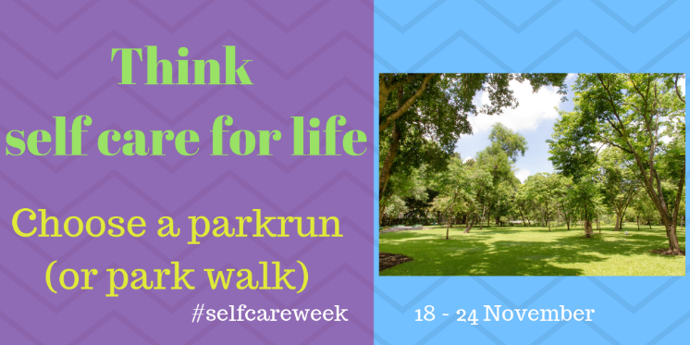
Wednesday | It’s #selfcareweek – time to stop and think #selfcareforlife and about protecting your mental wellbeing.Take time for yourself. Here is a link for advice on stress. http://bit.ly/33rAM32 and an app to help you with breathing techniques. http://bit.ly/2JZNsGA @SelfCareForum | 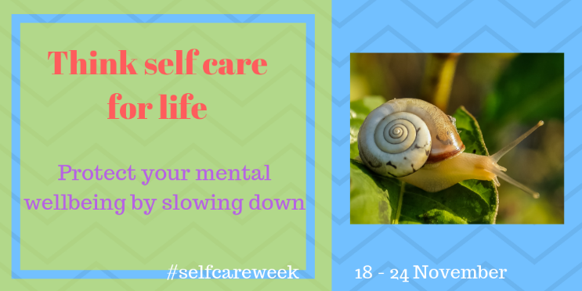
Thursday | It’s #selfcareweek and time to stop and think #selfcareforlife. Finding the right exercise for you is a great way to look after your long term and short term health. This free app can help. http://bit.ly/32uF9Ji  @SelfCareForum. | 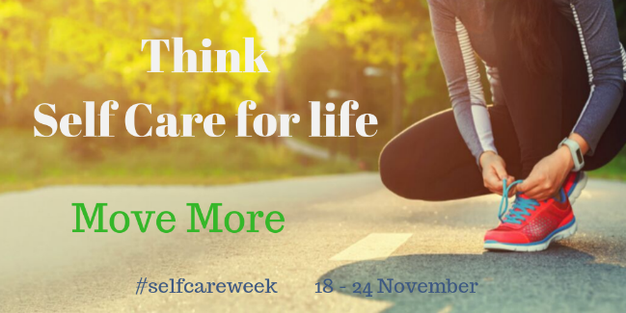
Friday | It’s #selfcareweek. Time to think #selfcareforlife. Are you getting a healthy balanced diet? Nutrition is essential to maintain physical health and mental wellbeing. Here are some tips. http://bit.ly/34KDgKm  @SelfCareForum | 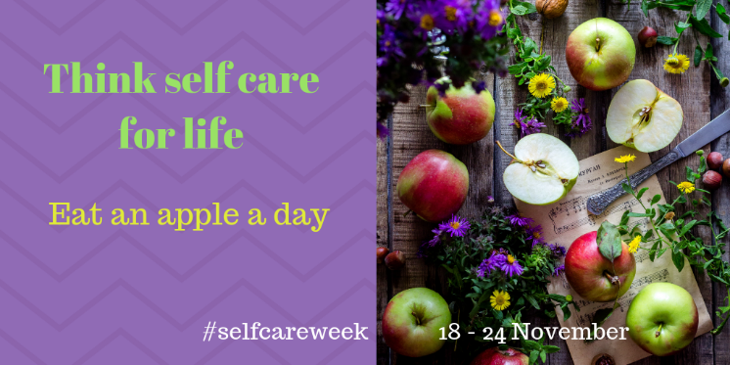
Saturday | It’s #selfcareweek – think #selfcareforlife and do one thing that will help you! Stopping smoking is one of the best ways to avoid preventable illness. The pharmacist can help with advice on how to quit. @SelfCareForum | 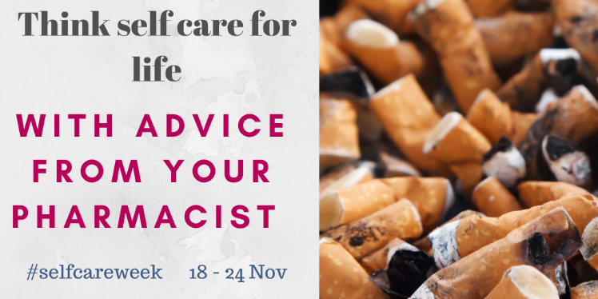
Sunday | Social interactions are known to be beneficial to our health and wellbeing. During #selfcareweek think #selfcareforlife and meet up with friends and family. @SelfCareForum. | 