Your logo 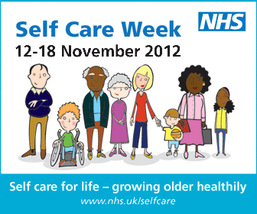

Sample Article
Learn to Look After Yourself as part of Self Care Week 2012
As part of our strategy on healthy living and patient empowerment, we are supporting Self Care Week 2012 to encourage people to look after their own health, and their family’s health.
The objective of the national Self Care Week 2012 is to raise awareness around self care and what people can do to stay healthy at home. The theme is “Self Care for Life - growing older healthily”, which builds on the European Active and Healthy Ageing initiative on improving the health knowledge of patients and the public as they get older. Self Care Week 2012 involves the whole continuum of life – from pre-birth to older years – to ensure healthy and happy living at every age.
We all know that we should be doing more to look after our own health, it’s all about MYCARENOW:
My health, my future – prevention is better than cure. Staying healthy starts with knowledge about the daily choices we make and the lifestyles we adopt throughout life – take a minute to find out what you can do for yourself, your children, your partners and your parents.
Y OLO (You Only Live Once) – make it count, make it safe, make it through your life.
Children first - education on self care starts with kids. Children make the best teachers when they’ve soaked up health knowledge from an early age.
Acne and more – you start to lay down the foundations of future behaviour in your teens so look at how health can become a part of your daily routine.
Reach for a century - soon 100 will be the new 60, so how will you want to feel? Start early and look after yourself and health. Take care to make sure you have your NHS when you need it.

Education is not just for kids – adults can learn how to look after their own health to ensure a long and healthy life.

NHS know-how – the NHS is there when you need help to self care. Check your symptoms on the NHS Choices website or call the NHS helplines

Overcome the fear of self care. Symptoms aren’t scary when you know what they are – find out about what’s wrong, learn about what you can do to help yourself and you’ll make the best of your health professional and your NHS.

When you’re poorly, there’s no place like home. Most everyday health problems can be cared for at home; with a little advice from your community pharmacist, the NHS helplines and websites you can take control and start to feel better quicker.

During Self Care Week 2012, we will be running a number of activities throughout the community in order to raise awareness around healthy living; we hope people will get involved to learn how to improve their health and their family’s health. For more details about activities please go to: [add your website information listing your activities].

