Self Care Forum Self Care Innovations Award 2021

Award Application Form and Eligibility

The Self Care Forum is inviting applications of good practice and innovations in self care, personalised care, and social prescribing that have made a difference to individuals, groups, or organisations.

Who can apply?
This invitation is open to everyone, whether you are an individual, a community champion, an employer, GP practice, Local Authority, school, college, business, or services organisation (public, private, or charitable). For a guide, see examples table below.

£500 bursary
The winner will receive a £500 bursary to spend on a self care related initiative and the top entries will be included on the Self Care Forum website to share best self care practice and excellence. The winners will be announced during the UK’s National Self Care Week (15 – 22 November) as part of its launch and promotional activity.

Closing date for admissions: 31st July 2021.

Examples of possible initiatives | If specific health-related conditions were targeted, they might include
- 2020’s Self Care Week activities  - Coronavirus related self care  - Signposting to services  - Protecting mental health and wellbeing  - Promoting self care to the shielded population  - Self care for the elderly or other specific groups  - Self care introduced by employers  - Local authority population or community initiatives  - Pharmacy initiatives  - GP initiatives  - Self care education by schools, universities, or community groups such as Scouts, Guides etc  - Empowering vulnerable groups | - Long-term conditions  - Obesity  - Diabetes  - General health  - Nutrition  - Exercise  - Mental Health  - Self-treatable conditions/minor illness

Please use the form below to tell us about your self care initiative.
If you are typing directly into the form, do not worry if the box extends beyond the page – it will continue onto the next one.

Title and contact details.
Title of Initiative (This should describe your initiative using 50 words max)
Being Virtually Brilliant! Upskilling health professionals to deliver remote health and well-being workshops.
Name of Organisation and Region (please state context, ie general practice, community care etc)
Cheshire & Merseyside Cancer Alliance
Name of person/team/individual being nominated
Workforce Team
Contact name for entry
Sharon Rowe
Contact email for entry
Sharon.rowe@nhs.net
Timeframe and dates of initiative
August 2020 - ongoing
Date of submission
1/06/2021

Problem(s) and how you tackled them.
What was the problem you were trying to tackle? (max 200 words)
Cheshire & Merseyside Cancer Alliance includes a network of thirteen
cancer provider Trusts covering a population of 2.5million. Personalised Strati􀃕ed Follow Up (PSFU) has been successfully implemented across the region for breast, colorectal, prostate and gynecology, tumour groups. Prior to registration on a remote monitoring system, patients are o􀃡ered an appointment to attend a workshop, delivered by Clinical Nurse Specialists
and Cancer Support Workers who provide tailored education and support to patients who have concluded primary cancer treatment. Patients can get advice regarding clinical/non clinical worries and also bene􀃕t from the support of other attendees. During the Covid 19 pandemic all physical workshops were paused and patients could not be registered for supported self management other than by a lengthy telephone conversation. There was a regional backlog of patients requiring workshops to enable supported self management
Please give a brief description of your self care innovation (max 250 words)
The team devised an interactive training session ‘Workshops without Walls ’ to improve digital skills of Clinical Nurse Specialists and Cancer Support Workers so that they could provide high quality virtual workshops to their patients. This was accompanied by a comprehensive Toolkit. The Toolkit contained a
series of step by step instructions on the setting up and delivery of a remote workshop, including creating patient invitations and email templates. There was also the o􀃡er of on going support which included a ‘dry run’ of a workshop with CMCA team prior to ‘going live’. Each virtual training session lasted 90 minutes. Eight sessions were offered during a three week period to provide flexibility to attend. The session included; Collaborative roles of CNS and CSW/N in virtual workshop facilitation, An understanding of MS teams functions (including practice), Step by step demonstration of how to create a patient invitation, How to plan for technical failures, Planning and design of workshops, Understanding timing, Being Brilliantly Virtual! understanding the challenges of virtual presenting and adapting communication skills for effective engagement

What challenges or barriers were you faced with and how did you solve the problems or overcome the barriers? (max 250 words)

Staff reluctant to engage with technology / engaging with patients remotely. Sessions were tailored to make them fun and interactive. Step by step guide produced. Offer for a dry ‘run through’ and help with workshop presentation (Powerpoint).

Did you collaborate with other partners or organisations, if so, who were they?

Impact and outcomes
Who was the initiative directed at and what were the benefits to the targeted group or individuals? (max 250 words)
Clinical Specialist Nurses, Cancer Support Workers/navigators and Macmillan Information staff.

Were there further benefits to you, your colleagues, your organisation or to a wider area such as the NHS? If so, what were they? (e.g improved job satisfaction, smoother running of facility, happier service users, better use of scarce resources, cost saving)

Patient feedback has been excellent.
Capacity released in outpatient clinics.
Capacity released for clinical staff to take on more complex clinical cases.

Evidence
Please quantify the benefits of your initiative. (e.g. cost improvement, numbers of people helped, time saved)
See above
>100 patients have attended the workshops.

Do you have formal or anecdotal evidence of success? (e.g. qualitative, quantitative, informal feedback?)
NARRATIVE FROM VIRTUAL GROUP WORKSHOP TRAINING (CNS & CSW/NAVIGATOR/MACINFO) MAY 2021
Is there anything you found particularly useful in the Part 1 training session today?
Just didn't know what I didn't know
How to blind copy. How to create terms link
All of it, I’m very keen with my CSW to do this for are patients
How to create invitations to the workshop
You were very basic, which was helpful
Very warm and welcoming, which put me at ease straight away. (Being totally new to Virtual Communications)
Although i have attended these workshops before, it has been more useful today as i only did my first patient workshop yesterday after having to reschedule due to tech failing on 1st workshop attempt.
na
It was all very useful and relevant.
N/A
Very clear instructions - great sharing of resources - thank you.
Explaining the additional functions of Teams, that I wasn't aware of.
Being shown how to blind copy patients in to emails and keeping confidentiality.
Yes, how you create the link
GREAT PRESENTATION
lots of useful bits about what to put in introduction email re security/confidentiality/general advice + weren’t aware that you could change text of hyperlink!
Simple instructions. Thank you.
I have been sending group Emails for years and had no Idea I could BCC and not share peoples Emails, this will be useful.
practical advice
I found the step by step instructions and demonstration helpful
templates looked straight forward and comprehensive
How to set up the meeting and a detailed explanation on the screen as well as sharing immediately via email
Just thought that the training session overall was very well put together and you have done the hard work for us with all the documentation, etc!
Simply explained and visual directions on how to use
very informative, easy to follow guide, will definitely be looking at incorporating this further into my practice

Is there anything you found particularly useful in the Part 2 training session today?
how to deliver using the technology
Tips on an interesting presentation
All of it , a good reminder of how to present
you both are amazing teachers
Showing how to use the chat box.
Felt comfortable asking 'stupid' questions. Such as how do you....take a screen shot. The problem is that most of use have picked things up as we have gone along.... not actually been taught. I played with a back ground before a session and couldn't get rid of it - very distracting!
The way Sharon and Lucy work together, shows me how a VGW Group runs smoothly, when don properly.
N/A
ideas to include in workshop such as videos/quiz
learning about backgrounds and other tips for camera
I found all aspects helpful and useful.
Looking at the presentation is sections - The set up, content and delivery - I found this really useful.
The importance of dummy runs to iron out any issues and to decide what will work and what won't.
All of it Lucy :)
IT SEEMED MORE STAIGHT FORWARD
THE SLIDES WERE GREAT
all the hints and tips
practical info relating to the quality of slides
The whole tools i found very useful
I feel I may have been relying on the presentation too heavily,
death my power point my ensue! I will take on board how and what I say in the workshop
the discussion about the slides and how to ensure good quality and also the background
This training session was clear, fun and engaging.
All of it! Just felt that I would feel more confident now to help my CNS deliver a virtual workshop to our patients.

What was the cost of this initiative in terms of time, money, and/or other resources? Please be as specific as you can

The Cancer Alliance allowed development of resources as part of workforce initiative to aid Covid recovery.

And, finally…
Are there any lessons you learned or top tips that you would like to share? (max 200 words)

Know your audience!

Did you use any of the Self Care Forum’s resources? If so, please specify.

Why do you think this initiative deserves to win the award? (Max 100 words)

Enabled upskilling of staff and proved that many patients who felt isolated were able to use technology to remain in contact with clinical staff
Do you have an image, materials or weblinks to supplement your application? Please supply no more than 2 images which may also be used to promote your application if successful.
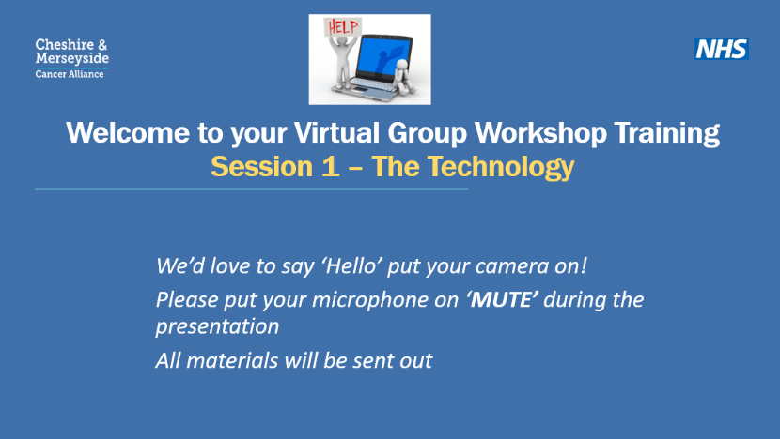
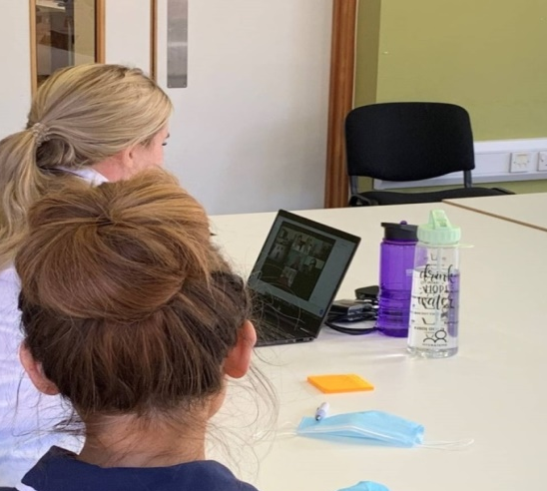

Your application may be chosen to be uploaded to the “best practice” page of the Self Care Forum website to share excellence so that others might use the learnings in your application to empower more people. We will also include your email address so that people may get in touch with you. Please give us permission below by choosing a, b or c (please delete the two that don’t apply).
- Yes I give permission for my application to be uploaded to the website with my contact details;
- Yes I give permission for my application to be uploaded to the website but would prefer my email address to be taken off;
- I would prefer not to have my application uploaded to the website.

We look forward to receiving your application. Please email your completed form to:
selfcare@selfcareforum.org

About the Self Care Forum
The Self Care Forum supports people-facing organisations in helping their communities and service users better understand how to self care. It is the leading independent provider of best practice around self care and the ‘go-to’ place for top quality resources, current opinion, and self care interventions in the UK.
It is a charity and aims to improve public health by promoting self care at national policy level. It creates resources, runs the UK’s National Self Care Week, and supports robust research evidence.

For more information about the Self Care Forum please go to the website. www.selfcareforum.org.

