Self Care Forum Self Care Innovations Award 2021

Award Application Form and Eligibility

The Self Care Forum is inviting applications of good practice and innovations in self care, personalised care, and social prescribing that have made a difference to individuals, groups, or organisations.

Who can apply?
This invitation is open to everyone, whether you are an individual, a community champion, an employer, GP practice, Local Authority, school, college, business, or services organisation (public, private, or charitable). For a guide, see examples table below.

£500 bursary
The winner will receive a £500 bursary to spend on a self care related initiative and the top entries will be included on the Self Care Forum website to share best self care practice and excellence. The winners will be announced during the UK’s National Self Care Week (15 – 22 November) as part of its launch and promotional activity.

Closing date for admissions: 31st July 2021.

Examples of possible initiatives | If specific health-related conditions were targeted, they might include
- 2020’s Self Care Week activities  - Coronavirus related self care  - Signposting to services  - Protecting mental health and wellbeing  - Promoting self care to the shielded population  - Self care for the elderly or other specific groups  - Self care introduced by employers  - Local authority population or community initiatives  - Pharmacy initiatives  - GP initiatives  - Self care education by schools, universities, or community groups such as Scouts, Guides etc  - Empowering vulnerable groups | - Long-term conditions  - Obesity  - Diabetes  - General health  - Nutrition  - Exercise  - Mental Health  - Self-treatable conditions/minor illness

Please use the form below to tell us about your self care initiative.
If you are typing directly into the form, do not worry if the box extends beyond the page – it will continue onto the next one.

Title and contact details.
Title of Initiative (This should describe your initiative using 50 words max)
Virtual Self-Care Week.
To promote living self-care for life and highlight its importance during these unprecedented times by using a holistic view of health and empowering individuals to take responsibility for their own health by signposting to services and activities and enabling engagement with wider communities.

Name of Organisation and Region (please state context, ie general practice, community care etc)
Baywide Primary Care Network including:
Compass House Medical Centres
Pembroke Medical Group
Chilcote surgeries.
The PCN covers 6 surgeries, general practice, across Torbay.

Name of person/team/individual being nominated
Baywide Social Prescribing Link Workers – Katrina Hill, Sabrina Libralon, Hermina Bulstrode
Contact name for entry Katrina Hill
Contact email for entry katrina.hill2@nhs.net
Timeframe and dates of initiative
Planning commenced in August 2020, this included collaborating with members of the PCN and other organisations, preparing information and designing activities.
The initiative was held during National self-care week 16-22 November 2020.

Date of submission 11/7/2021

Problem(s) and how you tackled them.
What was the problem you were trying to tackle? (max 200 words)

We were tackling social isolation and loneliness and mental ill-health and physical inactivity caused by the Coronavirus lockdowns and shielding. We recognised a need for support throughout all generations. Additionally, with increased pressure on staff, we wanted to enable them to maintain their wellbeing through the pandemic. We were also aware that patients were not wanting to visit their GP with restrictions in place.

We tackled these problems by offering self-care information and activities online, by collaborating with Healthy Lifestyles to improve physical health and mental health by increasing exercise at home, promoting healthy eating, and offering support to stop smoking.

Additionally, we raised awareness of services such as: Social Prescribing, Pharmacists and Carer Support Workers, based within surgeries. We empowered vulnerable groups, such as shielders, to connect to the wider community by enabling them to access online activities such as Tai Chi, coffee mornings, quizzes, and exercise classes. For staff, we conducted a big quiz to improve self-care knowledge and signpost to wellbeing resources. We educated school children about mental health through online classes. Using self-care forum resources, we held a pharmacy hour, educating patients to recognise minor ailments for self-care and when to visit the surgery.

Please give a brief description of your self care innovation (max 250 words)
Based on the results of a survey sent to our Patient Participation Groups, we assessed physical and mental health and awareness of support services. We then chose a topic for each day of self-care week to support those needs: Healthy Lifestyles, Social Prescribing, Carers Support, Mental Health and Combatting Loneliness and Isolation. Due to Government restrictions, we provided activities and information through Facebook and Twitter; each day an itinerary of activities was posted. We contacted Riviera FM to promote National Self-Care Week and our forthcoming event.

Activities were posted hourly each day. These included a video self-care quiz providing valuable information and signposting and enabled followers to see some cheerful, friendly faces. We posted testimonials of patients’ visits to signposted activities and their top tips for maintaining wellbeing during the lockdowns.

We led lessons for classes at Homelands Primary School: Year 1 explored how they are the same or different from their friends and learned how to feel better by thinking about things that make them happy. Year 5 explored diversity and culture.

Staff wore yellow socks to raise awareness of the ‘Lonely Not Alone’ initiative to give young people hope, support and solidarity; we posted fun pictures online. Our live big quiz encouraged healthy eating and exercise and signposted to self-care resources.

We collaborated with Healthy Lifestyles and they live streamed exercises our patients had chosen in a poll, their interactive Twitterchat answered questions and offered referrals. Carer Support Workers also held a Twitterchat, providing practical advice for carers.

What challenges or barriers were you faced with and how did you solve the problems or overcome the barriers? (max 250 words)

Reaching our audience
One surgery didn’t have Facebook, so we had to quickly build our followers, patients were emailed, and we promoted the page during telephone conversations.
Katrina was guest speaker on Riviera FM’s radio interview and promoted not only our activities, but also the National self-care week.
We were keen to host Twitterchat, as we had seen the details in the self-care resources, but had no Twitter account for the PCN, so we had to set up a Baywide account. However, by self-care week, we still had limited followers. So to ensure that the important Healthy Lifestyles and Carer Support Worker information reached all our followers we copied Twitter chat into our Facebook feeds.

Constantly changing COVID restrictions
We originally had plans to set up walking groups, visit the Orchard Forest School etc. However, with the aid of the resources on the self-care forum, we successfully held a virtual self-care week on behalf of our PCN, using existing and newly created social media pages.

Time constraints
We wanted a jammed packed week but hadn’t realized how time-consuming posting activities on Facebook was. Therefore, we used Business Suite to post things in advance which took the pressure off during self-care week. Our service was very busy during the pandemic, so we had to organize ourselves well and the meticulous preparation paid off.

Did you collaborate with other partners or organisations, if so, who were they?

We collaborated with:
- Carer Support workers within the PCN
- Baywide pharmacists
- Healthy Lifestyles – stop smoking, losing weight, increasing activity, eating more healthily
- Lupton Orchard Forest School – mental health support group
- Opportunuties/Pluss – helping patients back into work. They produced a unique film for our patients to promote the service.
- Homelands Primary School
- Riviera Radio
- The Wave Project
- Devon Highlights – Zoom coffee mornings and activities
- Mind

Impact and outcomes
Who was the initiative directed at and what were the benefits to the targeted group or individuals? (max 250 words)

The initiative was directed at all age groups including PCN followers, Patient Participation Groups, staff and school children, regardless of whether they attend one of our surgeries or not. However, we particularly wanted to target people who were struggling through the lockdowns.

For example, the Social Prescribers collaborated with Devon Highlights who put on a virtual coffee morning and Tai Chi class for the over 55s; this enabled us to attend and virtually meet patients. This gave vulnerable patients who had lost confidence, for example, from shielding, a boost to attend again in the future on their own.

Our videos, including a self-care quiz, were not just informative but fun and having not seen people for long periods of time, followers appreciated seeing familiar faces in their home which enhanced their mood.

It was beneficial to build connections with a local school and teach the children at a young age about self-care, with proactive mental health classes. The children demonstrated strategies to help them self-care, such as cuddling a baby sibling, or playing with Mum or Dad which they can continue to use when they feel unhappy.

Other vulnerable groups, such as carers, felt more supported during the isolating times, some were previously unaware that Carer Support Workers are based in each surgery.

We also promoted Social Prescribing which was a relative new service. This benefitted patients who need signposting to support for a wide variety of social needs now or in the future.

Were there further benefits to you, your colleagues, your organisation or to a wider area such as the NHS? If so, what were they? (e.g improved job satisfaction, smoother running of facility, happier service users, better use of scarce resources, cost saving)

We have had an increased rate of referrals to the Social Prescribing service and have expanded the team. Raising awareness of the Social Prescribing service will save GP time as patients will be addressing the root causes of their problems and the Social Prescribers will give them time to establish what matters to them which will also lead to happier service users.

We build up relationships with other teams within the surgeries which helps general practice to run more smoothly and we collaborated and networked with other services and VCSE organisations which will help us to signpost in the future.

Evidence
Please quantify the benefits of your initiative. (e.g. cost improvement, numbers of people helped, time saved)

We increased our Facebook and Twitter followers.
More followers interact in online groups and activities which helps to combat loneliness and isolation.
As a result from raising the profile of Social Prescribing on the radio and though the event, more patients now self-refer into the service. We supported 479 patients through the service from April 2020 – March 2021 and our referrals keep rising.
Healthy Lifestyles requested a Teams Meeting to find out how we managed the project so that they could use our best practice in the future.

Do you have formal or anecdotal evidence of success? (e.g. qualitative, quantitative, informal feedback?)

Qualitative – patient testimonials of activities they were signposted to were posted on our Facebook pages.
Quantitative – we now have 666 followers on our Chilcote page which was set up for self-care week which continues to provide information for self-care all year round.
82 patients from the Patient Participation Group responded to our pre self-care week survey which shaped our project.
We have 60 followers on Baywide Twitter which was set up for self-care week.
We had 5 referrals to the Social Prescribing service during self-care week alone.
We signposted one follower out of area and not a patient within our PCN.

What was the cost of this initiative in terms of time, money, and/or other resources? Please be as specific as you can

There was no budget, so no financial cost
The Social Prescribers spent 1 hour a week from Aug – Nov 2020 collaborating, designing activities and planning the event.
2 Social Prescribers cancelled their clinics to dedicate their time to self-care week during the event.

And, finally…
Are there any lessons you learned or top tips that you would like to share? (max 200 words)

The preparation for self-care week was intense, so it was imperative that enough time was set aside on a regular basis to cope with the task in hand. We were ambitious, as we wanted this to be bigger and better than before, but we were aware that we could not overload the team with unrealistic ideas.

Collaboration was key, so many people helped us to make the week a success and personalised it to our PCN so that we had unique selling points eg Opportunities filmed a clip for our followers, Healthy Lifestyles provided live exercises our patients had requested in a poll.

Posting on Facebook was extremely time consuming and tedious! So, allowing for posting prior to selfcare week on Business Suite was a life saver.

We had to be extremely flexible, Government restrictions were constantly changing so our plans had to as well to accommodate this. This required resilience, there was no option to give up, so we had to pick ourselves up after disappointment and start again! Who knows, maybe we can use those ideas for self-care week 2021!

Did you use any of the Self Care Forum’s resources? If so, please specify.

Yes, we used the following resources form the self-care forum:
- Twitter quotes
- Twitter Chat
- Posters
- 8-point plan
- Pharmacy posters
- Looked at best practice

Why do you think this initiative deserves to win the award? (Max 100 words)
Innovative

We were fully committed to the project and self-care week because we wanted to give something back to our followers and improve self-care and wellbeing. We constantly thought outside the box in difficult and changing circumstances and were flexible enough to change our project whenever necessary. We promoted not only the Social Prescribing role but others within the PCN, such as Carer Support Workers and Pharmacists, as patients wouldn’t necessarily have known about these before. We got followers to interact with us in a totally different experience to visiting the surgery and, importantly, we had fun and enjoyed the task!

Do you have an image, materials or weblinks to supplement your application? Please supply no more than 2 images which may also be used to promote your application if successful.

We made word art pictures for the year one children we taught as a thank you; these are the things that make the year 1 pupils feel happy:
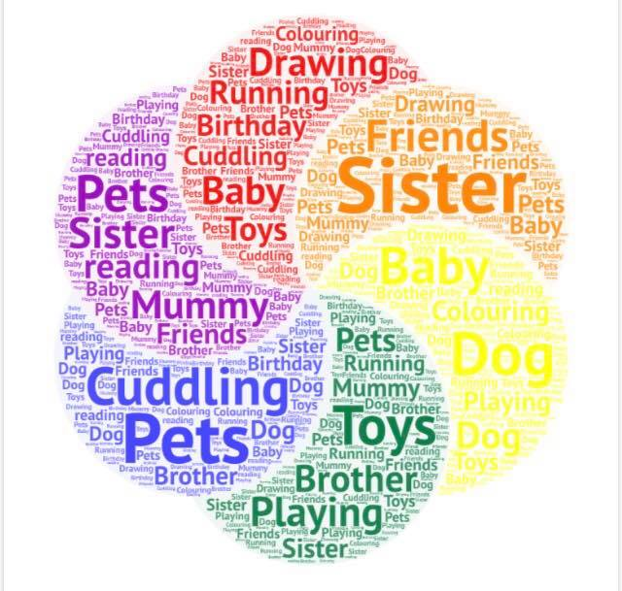

We collaborated with Healthy Lifestyles and following a patient poll, prior to self-care week, they put on these classes for our patients which we shared through our feeds:

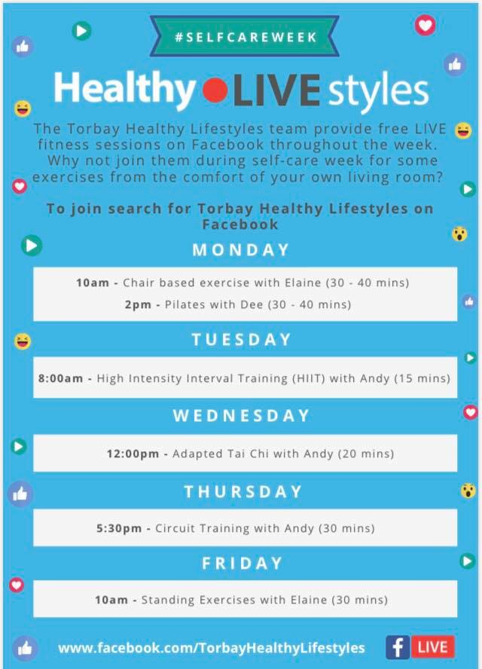

Your application may be chosen to be uploaded to the “best practice” page of the Self Care Forum website to share excellence so that others might use the learnings in your application to empower more people. We will also include your email address so that people may get in touch with you. Please give us permission below by choosing a, b or c (please delete the two that don’t apply).
- Yes I give permission for my application to be uploaded to the website with my contact details;
katrina.hill2@nhs.net

We look forward to receiving your application. Please email your completed form to:
selfcare@selfcareforum.org

About the Self Care Forum
The Self Care Forum supports people-facing organisations in helping their communities and service users better understand how to self care. It is the leading independent provider of best practice around self care and the ‘go-to’ place for top quality resources, current opinion, and self care interventions in the UK.
It is a charity and aims to improve public health by promoting self care at national policy level. It creates resources, runs the UK’s National Self Care Week, and supports robust research evidence.

For more information about the Self Care Forum please go to the website. www.selfcareforum.org.

