Self Care Forum Self Care Innovations Award 2022

Award Application Form and Eligibility

The Self Care Forum is inviting applications of good practice and innovations in self care, personalised care, and social prescribing that have made a difference to individuals, groups, or organisations.

Who can apply?
This invitation is open to everyone, whether you are an individual, a community champion, an employer, GP practice, Local Authority, school, college, business, or services organisation (public, private, or charitable). For a guide, see examples table below.

£500 bursary
The winner will receive a £500 bursary to spend on a self care related initiative and the top entries will be included on the Self Care Forum website to share best self care practice and excellence. The winners will be announced during the UK’s National Self Care Week (12 – 18 November) as part of its launch and promotional activity.

Closing date for admissions: 31st July 2022.

Examples of possible initiatives | If specific health-related conditions were targeted, they might include
- 2021’s Self Care Week activities  - Coronavirus related self care  - Signposting to services  - Protecting mental health and wellbeing  - Promoting self care to the shielded population  - Self care for the elderly or other specific groups  - Self care introduced by employers  - Local authority population or community initiatives  - Pharmacy initiatives  - GP initiatives  - Self care education by schools, universities, or community groups such as Scouts, Guides etc  - Empowering vulnerable groups | - Long-term conditions  - Obesity  - Diabetes  - General health  - Nutrition  - Exercise  - Mental Health  - Self-treatable conditions/minor illness

Please use the form below to tell us about your self care initiative.
If you are typing directly into the form, do not worry if the box extends beyond the page – it will continue onto the next one.

Title and contact details.
Title of Initiative: Digital Behaviour Change (Getting people the right information/services at the right time)
Name of Organisation and Region (please state context, ie general practice, community care etc): Kingston Council (London)
Name of person/team/individual being nominated: Kingston Public Health (Team)
Contact name for entry: Daniel Green
Contact email for entry: Daniel.green@kingston.gov.uk
Timeframe and dates of initiative: 2021/22
Date of submission: 8th July

Problem(s) and how you tackled them.
What was the problem you were trying to tackle? (max 200 words)

We quite often commission services or put information on websites, but the number of people taking up these offers can sometimes be small. Digital Behaviour Change aims to to increase the number of residents that see Self care information, access relevant services or sign up to an initiative. Specific problems we wanted to tackle in this case study 1) Accessing patient education videos, 2) Improving uptake of Weight Management services 3) Use of our Social Prescribing and community information portal – Connected Kingston 4) Uptake of Vaccination information and booking vaccination 5) Increasing sign ups of Kooth, online support for young peoples mental health

Please give a brief description of your self care innovation (max 250 words)
The Key aims of Digital behaviour change are to use advanced digital marketing practices, paired with behaviour change methodology and local service/community knowledge. The innovation across the 5 areas outlined are 1) Patient education videos were advertised on Facebook, targeted at over 50’s geographically in Kingston 2) Social media and and Search Engine Marketing (SEM) were used to target men in Kingston to drive uptake of new weight management services 3) SEM as well as Search Engine Optimisation (SEO) and wide range of social media tools including programmatic marketing were used to increase use of Connected Kingston 4) Vaccination promotion used all of the above, plus used local community videos which were shared over targeted social media and use of programmatic marketing to target inequalities in vaccination uptake 5) Social media campaigns were set up and designed to target younger residents, using younger person specific social media (Instagram and Snapchat)
What challenges or barriers were you faced with and how did you solve the problems or overcome the barriers? (max 250 words)

In all cases above (1-5) uptake was low of the desired intervention (whether a lack of people connected with self care information, a lack of men accessing weight management, inequalities in vaccination uptake and a need to advertise in multiple languages or a general lack of abilities to communicate with younger people through digital channels).

In each example we used innovative digital behaviour change methods to get results. Serving self care videos both within social media and links to the health education platform. Running 12 vaccination messages concurrently in 12 different languages, meaning we had 144 unique adverts running for vaccination at one time, with people only seeing the messages relevant to them / in the language that they speak. For younger people we studied, set-up testing and then ran a number of campaigns across Instagram and Snapchat – with good results and now these 2 platforms forming a key part of how we engage with younger people.

Did you collaborate with other partners or organisations, if so, who were they?

Yes, collaboration has been key to the success of these initatives. For 1) self care information campaigns for health education videos we partnered with the local Primary Care Network whose population we were targeting and the education video provider, 2) Weight management services were promoted on behalf of the health improvement team in collaboration with the weight management provider 3) Connected Kingston is a partnership between Council, Voluntary & Community Sector, NHS and other community partners 4) Vaccination was in support and on behalf of South West London CCG and 5) Imagery was supported by the provider of the Mental Health support (Kooth) and promotion on behalf of the CCG who commission the service

Impact and outcomes
Who was the initiative directed at and what were the benefits to the targeted group or individuals? (max 250 words)

- Self Care information: Using https://www.thesounddoctor.org/ material and videos, a number of campaigns were set up to promote relevant videos to support people to manage their long term health conditions, with summaries set up on Connected Kingston for each condition – this enabled people to see videos through advertising or to browse multiple conditions at their leisure (example page)
- Men typically take up weight management services at a far lower rate that women, so advertising sets were put together to target specifically men in the borough, who would benefit from the services once signed up
- Connected Kingston is our borough wide social prescribing platform, which is aimed at all residents to help connect people to services and social groups. Campaigns are designed to target each cohort differently, with considerations for age, location within the borough (we direct people to their most local activities online) and languages.
- Vaccination, again whilst aimed at most of the population, due to the partial release of vaccination by age group and the ongoing booster campaigns aimed at different groups, we used targeted marketing and programmatic marketing tools to segment our audience. So campaigns were run for parents of 5-11, or specifically for over 65’s when it was time for their booster
- Kooth, the mental health support platform is aimed at people aged 11-19. If people need support they can sign up to access counselling and resources to support their mental health. Campaigns were set up on social platforms such as Instagram and Snapchat aimed at this age group
Were there further benefits to you, your colleagues, your organisation or to a wider area such as the NHS? If so, what were they? (e.g improved job satisfaction, smoother running of facility, happier service users, better use of scarce resources, cost saving)

- Improved uptake of Health promotion materials on behalf of local PCN in relation to long term condition management
- Higher uptake of men in weight management services, more equitable access to services
- Very big increase in interest in community groups and people accessing community groups / awareness of local services
- Increased vaccination booking and information around vaccination being available in a more timely and equitable fashion (incl multiple languages)
- CCG commissioner has higher uptake of service

Evidence
Please quantify the benefits of your initiative. (e.g. cost improvement, numbers of people helped, time saved)

- Sound Doctor Long term conditions videos: 36,988 views of adverts across 10,407 residents. 319 people went onto the platform with 190 sign ups for more detailed LTC content
- Weight management campaign to increase men accessing weight management: 54 men signed up to the weight management services in a single campaign, a massive increase compared to regular sign up levels
- Connected Kingston has had record usership in 2022, the site is on track for 35k+ users and 120k page views, up from 6k users and 45k page views in 2019. Each campaign through Connected Kingston is either sharing health information pages/self care advice or is supporting people to access services or join a local community group. We have dozens of examples where campaigns have been run to increase numbers of people joining services and local community groups through Connected Kingston campaigns
- Vaccination campaigning. Initial vaccination campaigning and digital behaviour change was so successful we were commissioned to run campaigns across South West London. Recent campaigns have seen millions of impressions and 14k+ landings on the vaccination booking site page, driving local bookings of vaccination. We have also seen that clinics promoted in this way see higher turn up than those not promoted. We have also seen hundreds of thousands of views of vaccination messaging in the 12 top languages in the borough. This technique has allowed us to get out critical messages to many people rapidly – for example when messaging needed to go out around pregnant women and vaccinations or around blood clots and vaccination. The blot clots campaign gained 107k+ impressions with a click through of 18% (normal click through is 0.1 – 1%) showing a huge interest in this piece of health information, which was key to get to people before erroneous messaging reached people.
- Kooth – 1200+ people clicked through for further information, with 55 sign ups in a single month

Do you have formal or anecdotal evidence of success? (e.g. qualitative, quantitative, informal feedback?)

Partner organisations and community organisations have been very thankful for this quick and effective way to get messages out to residents in a targeted and high volume way. It is helping our community asset development approach by boosting local community group memberships

What was the cost of this initiative in terms of time, money, and/or other resources? Please be as specific as you can

We are incredibly lucky to have a very talented Public Health officer who delivers much of the design, digital set up, learning of different platforms and the delivery of these campaigns. This is part of his role.

Typically when we run campaigns we design using Canva, for which we pay around £10 a month

Campaign costs vary, we typically work on a £5-10 per day budget per campaign. A campaign may run for a few days or can run for up to a few weeks.

Programmatic marketing (automated buying of advertising) can be more expensive, with campaigns costing anywhere from £1k-£10k (or more!), but this is very much down to budget and campaign size. We used programmatic for Vaccination as there was urgency and funding to ensure messaging was as wide as possible. Total impressions for the programmatic work, keeping in mind the multiple languages, geo-targeting and other targeting – was estimated to be around 3million+ across the campaigns run for vaccination programme in Kingston

And, finally…
Are there any lessons you learned or top tips that you would like to share? (max 200 words)

Believe in your teams and let them learn. We have benefitted greatly from enabling staff to learn new programmes, learning from younger staff who use new social media platforms and a key mantra of investing in the promotion and digital tools, as well as simply commissioning services or creating webpages.

It is worth noting we are willing to share the skills behind these projects and share with other organisations to empower using these techniques
Did you use any of the Self Care Forum’s resources? If so, please specify.

The Self Care Forum site and resources have been valuable, particularly around the self care continuum. The learning from the site and past webinars/ involvement with the Self Care forum in a previous role

Please state your social media addresses including all those who were involved in the initiative.

Connected Kingston and RBKingston accounts across Twitter, Facebook, Instagram, Snapchat and other smaller platforms or business platforms – e.g. Google
Why do you think this initiative deserves to win the award? (Max 100 words)

To our knowledge this is the first mass use of Digital behaviour change marketing for Public Health/Self-Care/Community, with proven results and mass reach. We believe that this approach can reduce inequalities, improve equity of service access and can build community. We also believe that there is lots more we can achieve, including patient education and patient diversion for the NHS
Do you have an image, materials or weblinks to supplement your application? Please supply no more than 2 images which may also be used to promote your application if successful.

https://www.connectedkingston.uk/
Presentation summary of our approach (includes graphics, moving adverts and data behind some of the work described above)

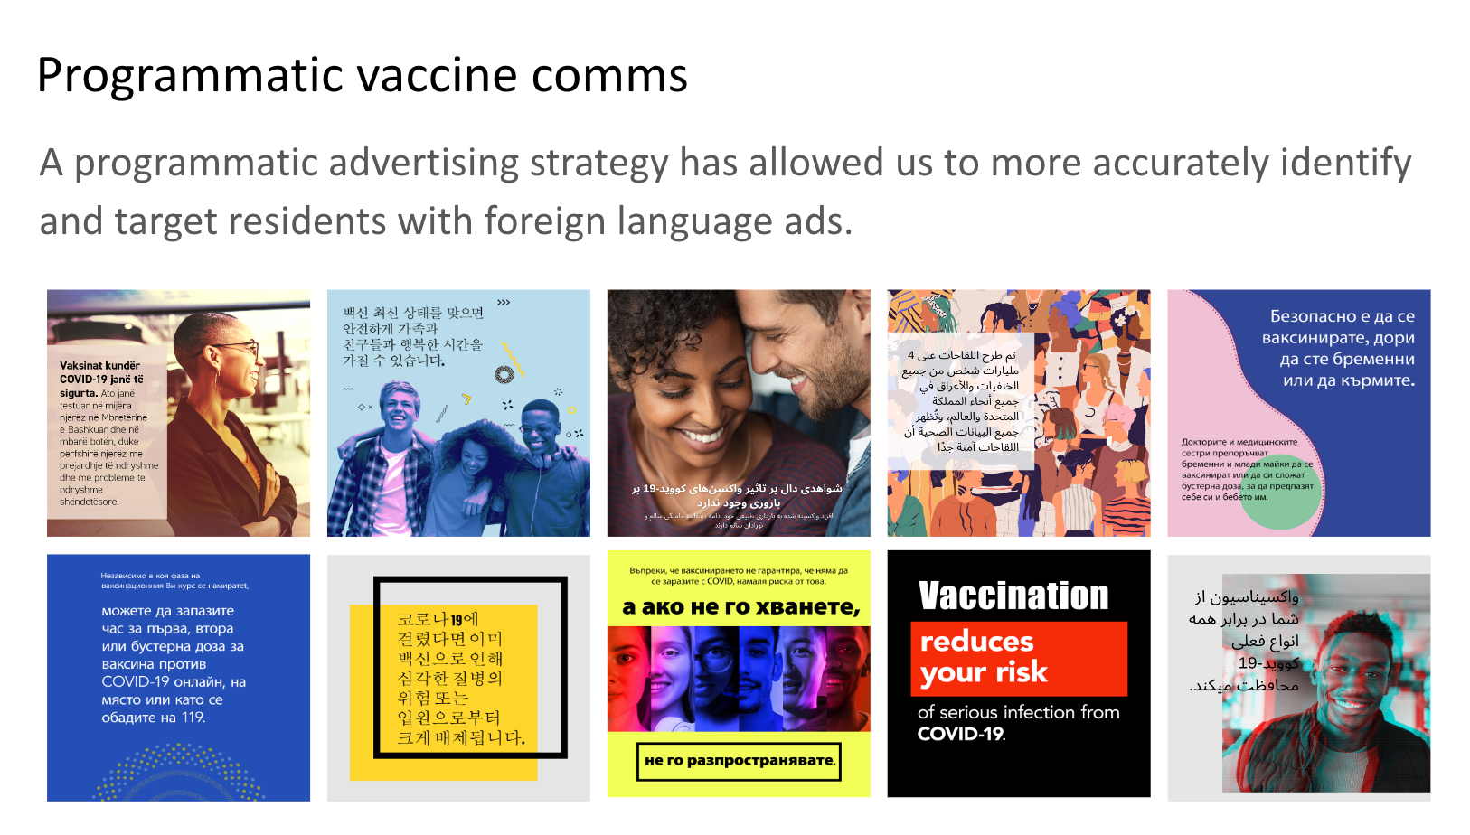
Fig 1: Vaccination key messages, in top locally spoken languages in Kingston. Part of the 144 concurrently running advertisements – personalising vaccination messaging for residents

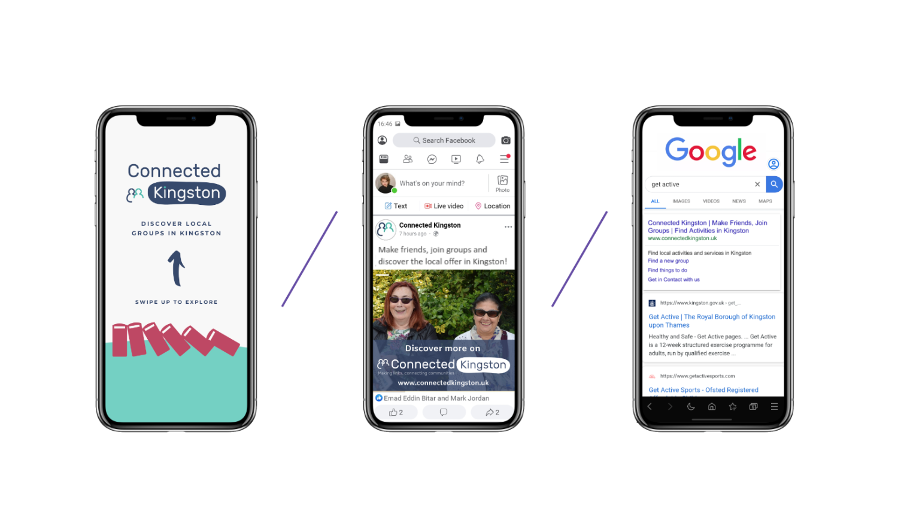
Fig 2: Advertising across multiple platforms – (left to right) Snapchat, Facebook and Google (SEM)

Your application may be chosen to be uploaded to the “best practice” page of the Self Care Forum website to share excellence so that others might use the learnings in your application to empower more people. We will also include your email address so that people may get in touch with you. If you would prefer that your application and/or email address was NOT chosen then please make it clear in the box provided below.
We look forward to receiving your application. Please email your completed form to:
selfcare@selfcareforum.org

About the Self Care Forum
The Self Care Forum supports organisations in helping their communities and service users better understand how to self care. It is the leading independent provider of best practice around self care and the ‘go-to’ place for top quality resources, current opinion, and self care interventions in the UK.
It is a charity and aims to improve public health by promoting self care at national policy level. It creates resources, runs the UK-wide National Self Care Week, and supports robust research evidence.

For more information about the Self Care Forum please go to the website. www.selfcareforum.org.

