Self Care Forum Self Care Innovations Award 2022

Award Application Form and Eligibility

The Self Care Forum is inviting applications of good practice and innovations in self care, personalised care, and social prescribing that have made a difference to individuals, groups, or organisations.

Who can apply?
This invitation is open to everyone, whether you are an individual, a community champion, an employer, GP practice, Local Authority, school, college, business, or services organisation (public, private, or charitable). For a guide, see examples table below.

£500 bursary
The winner will receive a £500 bursary to spend on a self care related initiative and the top entries will be included on the Self Care Forum website to share best self care practice and excellence. The winners will be announced during the UK’s National Self Care Week (12 – 18 November) as part of its launch and promotional activity.

Closing date for admissions: 31st July 2022.

Examples of possible initiatives | If specific health-related conditions were targeted, they might include
- 2021’s Self Care Week activities  - Coronavirus related self care  - Signposting to services  - Protecting mental health and wellbeing  - Promoting self care to the shielded population  - Self care for the elderly or other specific groups  - Self care introduced by employers  - Local authority population or community initiatives  - Pharmacy initiatives  - GP initiatives  - Self care education by schools, universities, or community groups such as Scouts, Guides etc  - Empowering vulnerable groups | - Long-term conditions  - Obesity  - Diabetes  - General health  - Nutrition  - Exercise  - Mental Health  - Self-treatable conditions/minor illness

Please use the form below to tell us about your self care initiative.
If you are typing directly into the form, do not worry if the box extends beyond the page – it will continue onto the next one.

Title and contact details.
Title of Initiative
“Healthy Groups”: Group Clinics to support complex long term conditions
Name of Organisation and Region (please state context, ie general practice, community care etc)
Citizens Advice South Northants, North Oxfordshire and Cherwell District Council working with primary care and social care.
Name of person/team/individual being nominated
Dr Ellen Fallows
Contact name for entry
Dr Ellen Fallows
Contact email for entry
ellenfallows@nhs.net
Timeframe and dates of initiative
18/5/21 – 01/07/22
Date of submission
29/7/22

Problem(s) and how you tackled them.
What was the problem you were trying to tackle? (max 200 words)

We wanted to address the challenge of supporting people with complex and long-term health issues such as chronic pain, low mood, obesity, type-2 diabetes, cancer and menopause in primary care. Workforce shortages and increased demand post-COVID-19 mean that primary care appointments are short, over-whelmed and in high demand. This leaves people with many long term and complex health issues with little support. Secondary care waiting list are also at least 6 months now for many people.
Many people with these conditions were shielding and became very isolated. Research has found that social isolation is known to be a bigger risk factor for poor health than smoking and obesity combined.
Remote consultations can become very transactional, and doctor focused. Evidence suggests that video group clinics can give people more time to talk about what matters to them and shift the conversations to patient values.

Please give a brief description of your self-care innovation (max 250 words)
Group clinics are a tried and tested way to see up to 10 people with similar health conditions or concerns. They are structured sessions with a trained facilitator with a health coach background who sets up the group and supports people to come up with their questions or concerns for the clinician. After a short break when the clinician is debriefed, the clinician consults with each patient in the group, ensuring that everyone has a chance to discuss their concerns. The group often then supports each other and problems solves together. The clinician then leaves the facilitator to wrap-up and help people to set health goals and sign-posts them to further support within the community. The clinician then writes to the patient’s own GP if referrals or medication changes are needed for example.
In this project a health coach was trained, promotional material and pre-session health questionnaires were made.
31 group clinics were set up. 141 patients booked into a group and 100 patients attended their group. Patients were from 9 different GP practices across South Northamptonshire and North Oxfordshire, including 2 groups for AGE-UK social prescriber employees. 28 participants came from a more deprived ward of Banbury. All but 4 of the group clinics were delivered virtually with 24 participants attending face-to-face groups. The majority of participants (96/100) were women with an average age of 56 years.
We evaluated this new model of care using Patient Reported Outcome Measures.
What challenges or barriers were you faced with and how did you solve the problems or overcome the barriers? (max 250 words)

Patient Recruitment
Getting information about group clinics out to patients was a major challenge during the Winter period. We had hoped to be working closely with the practices in the PCN but developing an effective working relationship as an external service was very difficult. For example, it took until March 2022 to obtain an honorary contract and have access to the electronic patient record to be able to send texts and record in patient notes etc. Much of this delay was due to the huge administrative burden on primary care Nov-Dec 2021 when we were trying to recruit patients to the programme. At this time practices were focused on manging staffing issues due to covid and running the vaccine programme in the face of a threatened Omicron wave. All usual practice activities were paused for a period during December 2021.
As a result, we also offered video group clinics direct to patients through local advertising.
Further details around our quality improvement approach are listed below:

Patient recruitment strategies used;
  - Banners and leaflets in surgeries; very few patients were attending in person, one surgery had locked their doors to patients for example.
  - Social media posts; initial posts were not clear that the service was free i.e. NHS provided and didn’t focus on specific conditions. In later posts it was made clearer that this was am NHS service and the offer was advertised to more specific patient groups
  - Meetings with clinicians; meetings with social prescribers, pharmacists, nurses, GPs were all successful and enthusiastically attended with agreements that they would discuss with patients but on subsequent meetings people admitted to having forgotten to do so. Workload was cited as well as other conflicting issues in very short appointments.
  - Engagement events with patients; webinar was not attended despite texts to patients, however, the in-person meeting at the cancer centre was well attended.
  - Texting patients; the two groups that one surgery agreed to text were chosen by them to be people with Type-2 Diabetes with a very raised average blood sugar and those over-using opiate medications. No one replied to the group offer from these text messages. Phone calls to a 10 patient sample from these lists revealed these were a group of patients with very complex health care and social needs who were not engaging even in usual primary care. It was unlikely therefore that this group would be able engage in a new, on-line service. Many reasons cited were overwhelming social issues that prevented them from being able to prioritise their health needs as well as on-line access issues and lack of confidence in attending such a group.
  - Evening groups; evening group clinics were offered but this didn’t improve up-take.
  - Groups on different days; groups on Fridays and Tuesdays were offered with no change in up-take.
  - Engagement with Population Health Project in Banbury PCN; this group had already targeted a group of patients in need of healthcare (joint problems) and who were engaging in health care provision (patients had requested referral to secondary care) but were on a waiting list to be seen at the hospital. We texted this group of patients with the offer of in-person or video group clinics with much improved up-take. We offered both virtual and in-person groups to this cohort who were from a more deprived area. The face-to-face groups were more popular.
  - Focusing on specific health conditions: our most popular groups were around low mood, type-2 diabetes, chronic pain and the menopause. When we focused on these conditions we had improved up-take. Menopause was by far the most popular.

- NHS funded PAM scores withdrawn
NHS funding for PAM scoring was withdrawn in August 2021. We moved to use an equivalent Patient Reported Outcome Measure (PROM).

Did you collaborate with other partners or organisations, if so, who were they?

Yes – Primary Care Network, Population Health Alliance, Citizens Advice, Cherwell District Council. This was quite a uniquely cross-disciplinary team.

Impact and outcomes
Who was the initiative directed at and what were the benefits to the targeted group or individuals? (max 250 words)

Directed at people with complex long-term conditions who were happy to join an in-person or video group clinic.

Benefits measured:
Most survey respondents felt that group clinics were easy to access and acceptable to them.
See results in table 1 below:

Statement | % of survey respondents (n = 41)
Felt it was easy to sign up and access a group clinic | 76
Would recommend a group clinic to others with similar health concerns | 95
Felt it was useful to hear other people’s experiences in the group clinic | 95
Felt comfortable sharing their health concerns in a group setting | 98
Felt they had more time to explore their health concerns and have their questions answered | 90
Table 1: Percentage of post-group survey respondents agreeing with the listed statements

Free text feedback
Four key themes emerged around social connection, new ideas, more time and a pleasant atmosphere in the group. The most commonly mentioned theme was that group clinics provided social connection, validation and the benefit of meeting others with similar concerns.

These themes were grouped for analysis:
Theme | Number of comments | Comments
Social connection/validation/meeting others with similar concerns | 26 | “Surprisingly others just like me with same issues.”  “to be able to bounce off others with similar concerns.”  “They are a much-needed lifeline in this Covid world we now live in. A chance to meet other people in similar circumstances. Helps to feel less isolated.”  “Particularly interesting to talk to someone who actually has diabetes. That alone made me feel I must really help myself as a prediabetic person and take my health much more seriously.”  “The small group clinic allowed you to comfortably share your concerns and experiences and have that validated by other members of the group and allow further discussion points to be opened up”  “Shared information, supportive, safe, others with similar symptoms,”  “collaborative”  “I learned so much from listening to the other participants experiences”  “The fact that the illness symptoms were valid when I related them and I was heard!”  “interaction with fellow patients”  “I very much enjoyed being part of a group and hearing the advice and experiences of other people..”  “meeting with patients”  “shared experiences”  “talking with people with the same issues”  “sharing with other participants”  “Hearing others worries and offering each other feedback.”  “Knowing that others have similar issues and questions.”  “Light bulb moments after listening and hearing others stories”  “Hearing other people’s experiences was very useful”  “the other group members talking about their experiences”  “Excellent to hear the experiences of others”  “I learned from other women’s questions”  “listening to other people”  “meeting others”  “listening to other people’s stories and advice e.g. what they have tried”  “feeling I’m not on my own”
New ideas/sharing ideas/empowerment | 8 | “get a different perspective on health issues”  “Learning about others’ experiences is always helpful, often you can pick up tips. Also, groups do tend to encourage each other.”  “brilliant ideas”  “picked up some hints and tips”  “Very useful for similar experiences and alternatives” “The session made me feel empowered, knowledgable and inspired”  “alternative perspectives”  “supportive and empowering”  “made me feel empowered”
More time/more information | 9 | “Very well managed including a clinical perspective and individual concerns addressed in the group in a safe way with current thinking and research references.”  “Really informative and informal which I liked so I would recommend.”  “I got so much more information that I would of in a regular GP appointment.”  “hearing about more research”  “ask questions I haven’t been able to ask”  “in depth information”  “advocate for choice of treatment”  “decent chunk of time from a professional”  “time for each participant to be heard and have feedback”
Comfortable atmosphere in the group | 7 | “reassuring”  “very relaxed. Felt listened to”  “really enjoyed the format”  “I was so amazed how brilliant the session was, I was extremely nervous discussing about my medical issues in this way, but it was ok.”  “comfortable”  “efficient and safe”  “comfortable about talking about concerns and listened to”

What could be improved
Participants were asked what they didn’t enjoy or could be improved. 26/40 respondents said they wouldn’t change anything. 3 people mentioned having more time or follow-up sessions.

Goal setting
At the end of the group, the health coach supported people to set health goals that were specific, measurable, time-bound and realistic. 87% of respondents reported having made a health goal and 71% felt very confident or confident that they could achieve this goal following the group.

Enablement Scores
See graphics below for results where respondents were asked, “After attending the group clinic, to what extent do you feel you are………. ”:

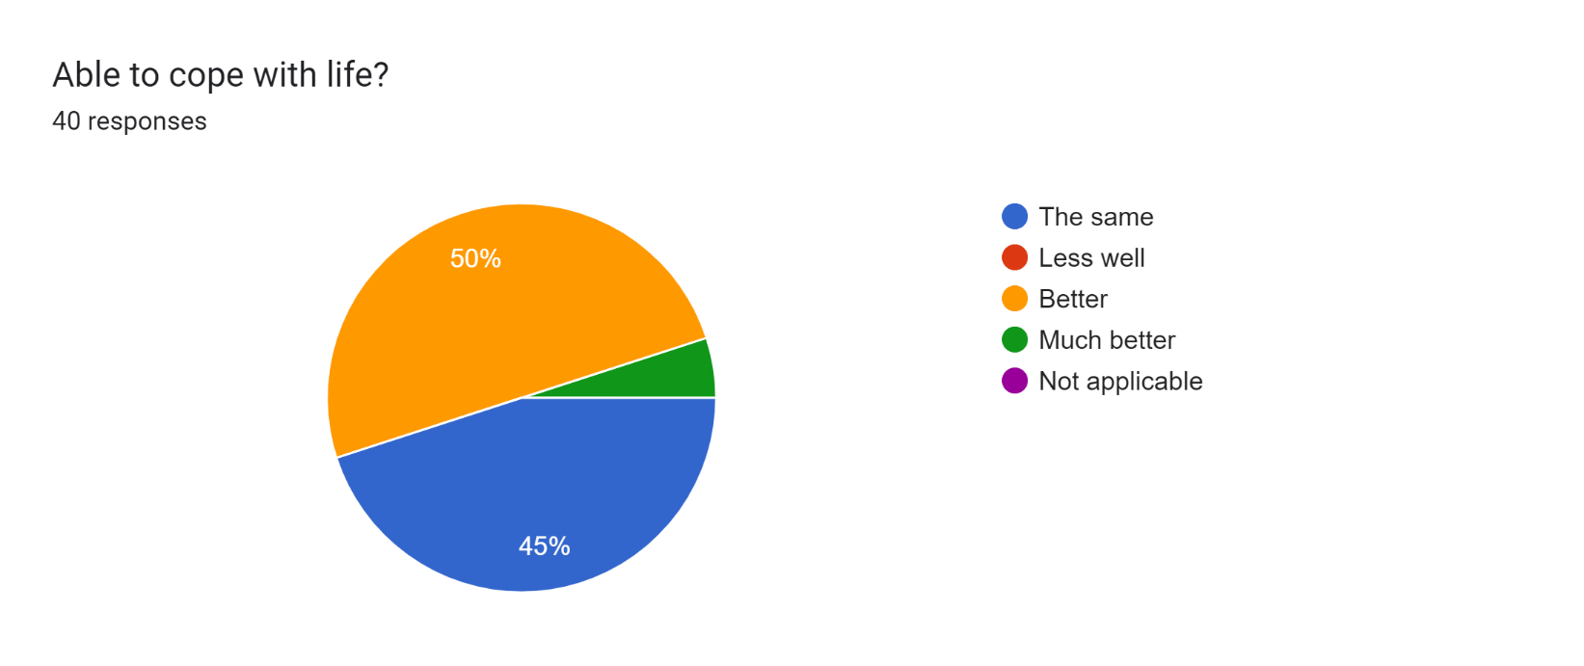

F 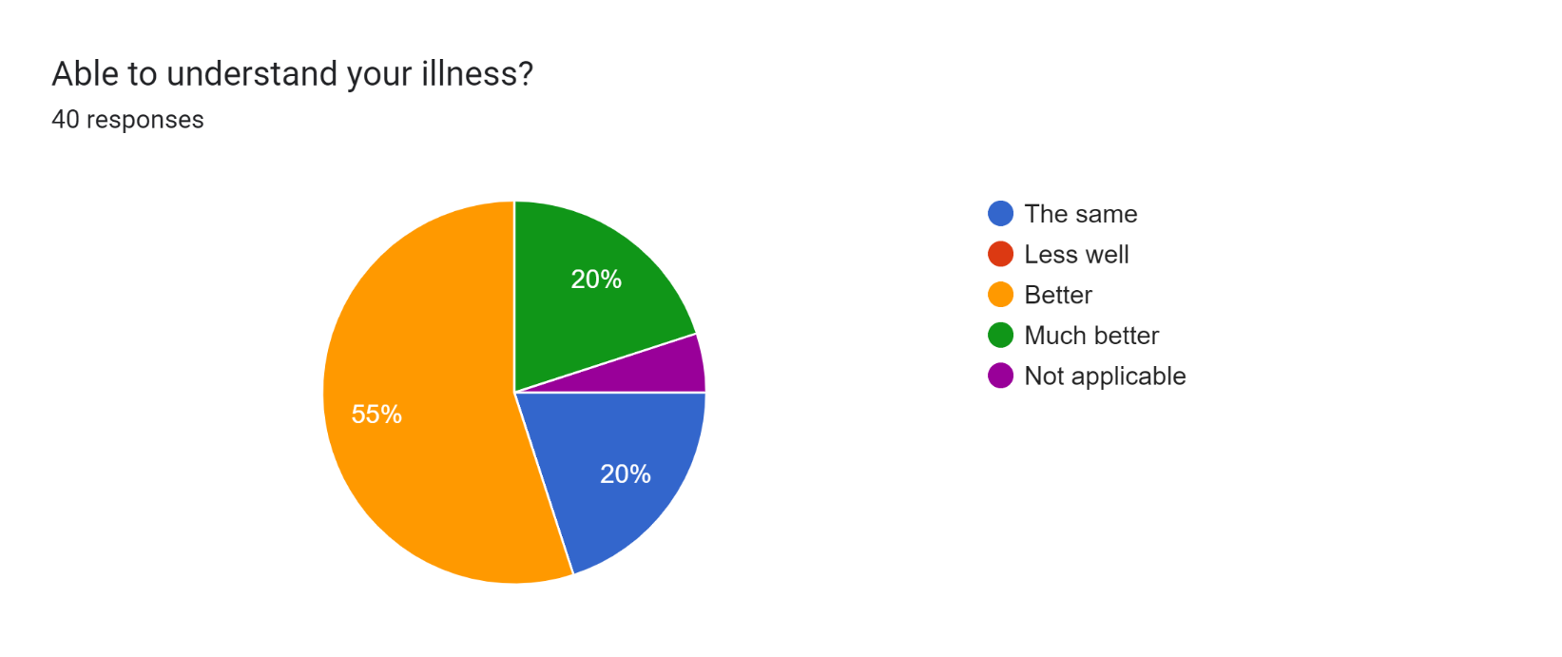

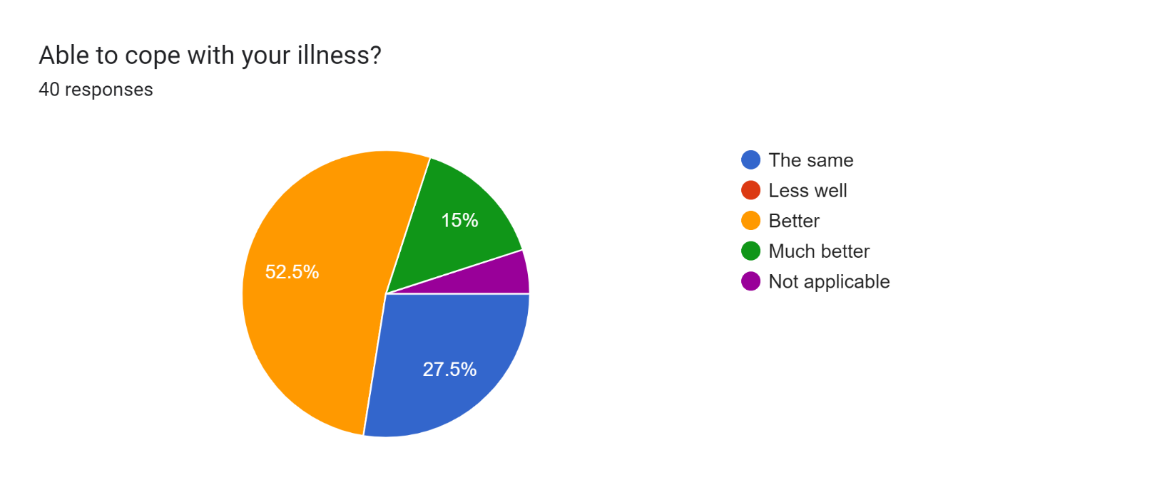

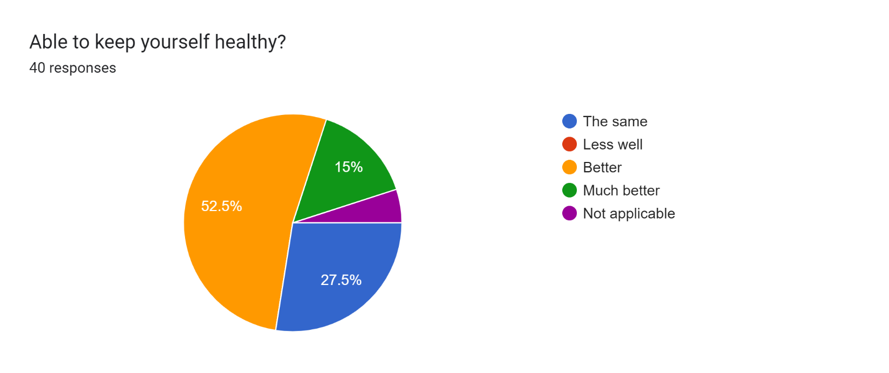

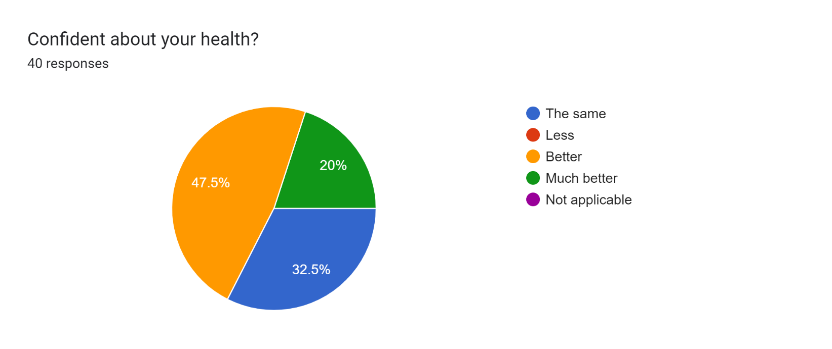

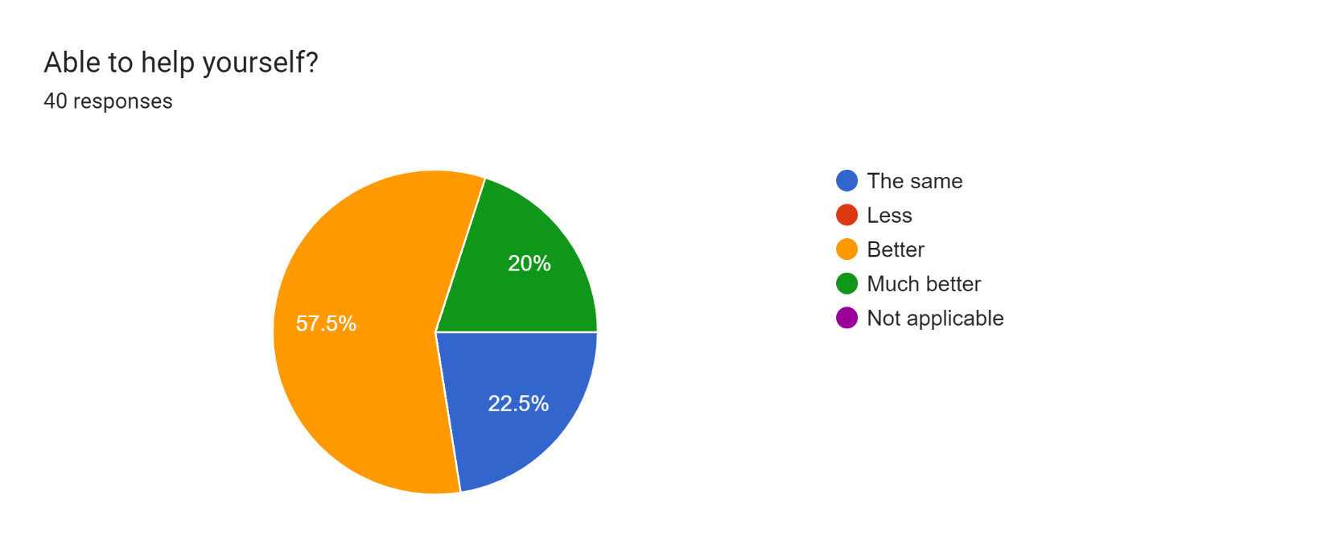

Were there further benefits to you, your colleagues, your organisation or to a wider area such as the NHS? If so, what were they? (e.g improved job satisfaction, smoother running of facility, happier service users, better use of scarce resources, cost saving)

The clinician consulting in the group clinic reports “Group clinics allow me to down shift and move away from brief, transactional appointments to having longer and more relaxed conversations with people. This has meant I can get to the crux of what matters to people much more quickly. Working in groups is much more collaborative; I no longer feel overwhelmed and that I need to fix everything for the patient. It feels like we are all in this together and people leave feeling empowered and with a plan that they have decided is important to them. It has been completely liberating and renewed my energy as a GP. I think this is the only effective way to support people with multiple complex health problems.”

Group clinics allow for multiple clinicians and health care providers to work together. A significant challenge in primary care is integrating the new additional roles such as social prescribing link workers, physios, pharmacists and health coaches. In a group clinic, all these roles can work together, learn from each other and complement each others’ skills.
Group clinics mean that up to 15 people can be seen by a clinician per hour. This is particularly cost and time efficient. Patients who don’t turn up “DNA” are not a problem as the clinician then gets longer to spend with the rest of the group. Frequent attenders are also not a problem as they can become the group expert patient for example.

Evidence
Please quantify the benefits of your initiative. (e.g. cost improvement, numbers of people helped, time saved)
Please see impact and outcomes section.
Patient Enablement Scores improved for the majority of patients attending group clinics. There is evidence that increased enablement is associated with improved health outcomes and reduced healthcare use.

Do you have formal or anecdotal evidence of success? (e.g. qualitative, quantitative, informal feedback?)
See impact and outcome section; qualitative feedback.

What was the cost of this initiative in terms of time, money, and/or other resources? Please be as specific as you can
The programme was run with a budget of £20,000 using resources from Citizens Advice and Cherwell District Council to support project management, accounting, evaluation and marketing.

And, finally…
Are there any lessons you learned or top tips that you would like to share? (max 200 words)

Setting up a new model of care during Covid-19 is challenging; perseverance is key.
Focusing on building trust and relationships with key stakeholders in your area for example PCNs, STPs, Health and Wellbeing boards, District Council, charitable groups and interested individuals (including patients), is really important.
Plan evaluation into the project from the start and use validated patient reported outcome measures.

Did you use any of the Self Care Forum’s resources? If so, please specify.

No.
Please state your social media addresses including all those who were involved in the initiative.
@ellenfallows
Why do you think this initiative deserves to win the award? (Max 100 words)

This is a multi-disciplinary team project that has delivered a new model of care with the potential to improve patient self-care and enablement, access to healthcare whilst reducing social isolation and supporting people with complex, long-term health conditions. It may also reduce the risk of clinician burn-out and bring the primary care team together. It has the potential to be rapidly scaled-up to address the many challenges facing the NHS today.

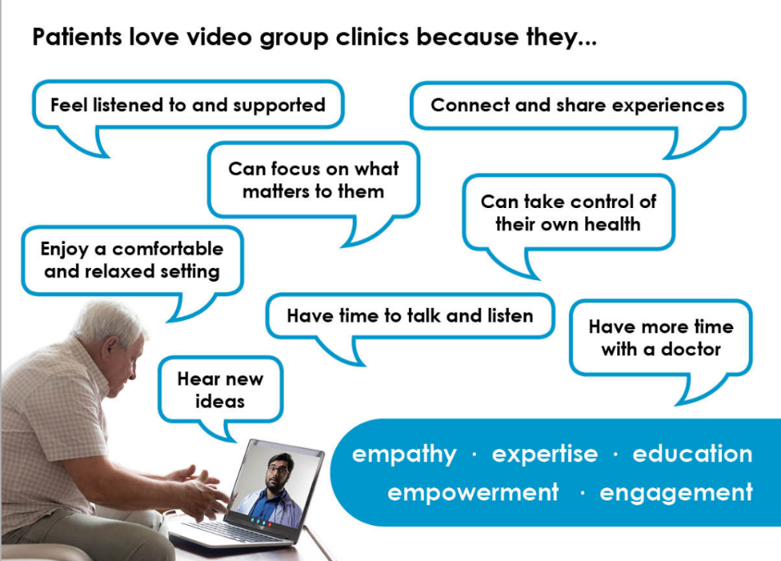
Do you have an image, materials or weblinks to supplement your application? Please supply no more than 2 images which may also be used to promote your application if successful.
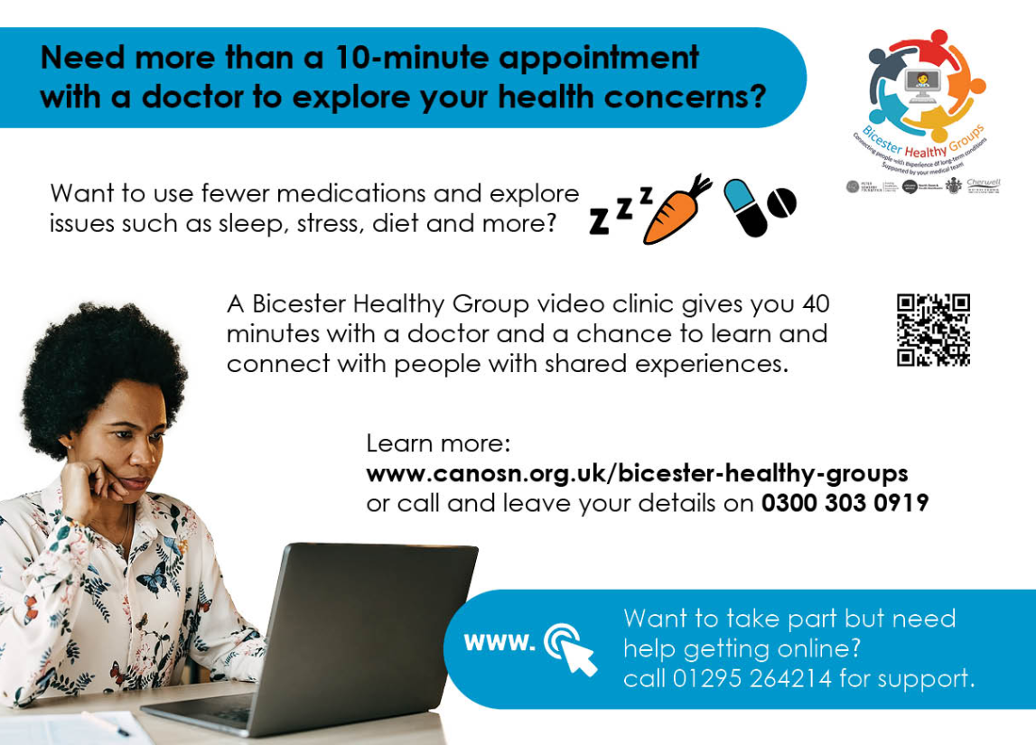
Your application may be chosen to be uploaded to the “best practice” page of the Self Care Forum website to share excellence so that others might use the learnings in your application to empower more people. We will also include your email address so that people may get in touch with you. If you would prefer that your application and/or email address was NOT chosen then please make it clear in the box provided below.
We look forward to receiving your application. Please email your completed form to:
selfcare@selfcareforum.org

About the Self Care Forum
The Self Care Forum supports organisations in helping their communities and service users better understand how to self care. It is the leading independent provider of best practice around self care and the ‘go-to’ place for top quality resources, current opinion, and self care interventions in the UK.
It is a charity and aims to improve public health by promoting self care at national policy level. It creates resources, runs the UK-wide National Self Care Week, and supports robust research evidence.

For more information about the Self Care Forum please go to the website. www.selfcareforum.org.

