Self Care Forum Self Care Innovations Award 2022

Award Application Form and Eligibility

The Self Care Forum is inviting applications of good practice and innovations in self care, personalised care, and social prescribing that have made a difference to individuals, groups, or organisations.

Who can apply?
This invitation is open to everyone, whether you are an individual, a community champion, an employer, GP practice, Local Authority, school, college, business, or services organisation (public, private, or charitable). For a guide, see examples table below.

£500 bursary
The winner will receive a £500 bursary to spend on a self care related initiative and the top entries will be included on the Self Care Forum website to share best self care practice and excellence. The winners will be announced during the UK’s National Self Care Week (12 – 18 November) as part of its launch and promotional activity.

Closing date for admissions: 31st July 2022.

Examples of possible initiatives | If specific health-related conditions were targeted, they might include
- 2021’s Self Care Week activities  - Coronavirus related self care  - Signposting to services  - Protecting mental health and wellbeing  - Promoting self care to the shielded population  - Self care for the elderly or other specific groups  - Self care introduced by employers  - Local authority population or community initiatives  - Pharmacy initiatives  - GP initiatives  - Self care education by schools, universities, or community groups such as Scouts, Guides etc  - Empowering vulnerable groups | - Long-term conditions  - Obesity  - Diabetes  - General health  - Nutrition  - Exercise  - Mental Health  - Self-treatable conditions/minor illness

Please use the form below to tell us about your self care initiative.
If you are typing directly into the form, do not worry if the box extends beyond the page – it will continue onto the next one.

Title and contact details.
Title of Initiative
Self-Care Toolkits
Name of Organisation and Region (please state context, ie general practice, community care etc)
North Yorkshire County Council (Local authority)
Name of person/team/individual being nominated
North Yorkshire Library Service
Contact name for entry
Melanie Fowler
Contact email for entry
Melanie.fowler@northyorks.gov.uk
Timeframe and dates of initiative
Development of project April – December 2021. Toolkits launched January 2022. Project ongoing.
Date of submission
29.7.22

Problem(s) and how you tackled them.
What was the problem you were trying to tackle? (max 200 words)

In recognition of a substantial national rise in rates of mental health disorders amongst young people age 11+, exacerbated by the effects of Covid and lockdowns, we wanted to provide a resource for individuals or groups to borrow to promote and encourage the practice of self-care and enhance mental wellbeing.

According to the NHS Survey Mental Health of Children and Young People in England 2021, rates of probable mental disorders have increased since 2017; in 6 to 16 year olds from one in nine (11.6%) to one in six (17.4%), and in 17 to 19 year olds from one in ten (10.1%) to one in six (17.4%). 39.2% of 6 to 16 year olds had experienced deterioration in mental health since 2017and among 17 to 23 year olds, 52.5% experienced deterioration.

Alongside our existing provision of the Reading Well Shelf Help book collection with titles on specific topics, we wanted to provide a more interactive resource which would stimulate young people to think more broadly about mindfulness and general wellbeing, together with information on support organisations which young people borrowing the kit can keep for future reference, even if they feel they do not need any support at the time.

Please give a brief description of your self care innovation (max 250 words)
The Self-Care Toolkit is a portable collection of items, books and activities designed to encourage young people (11+) to practice self-care and enhance mental wellbeing.

50 kits are available to be requested and borrowed from any of our 42 libraries, free of charge for 3 weeks using a library card. The toolkits can be used by individuals or groups at home, in the library or out in the community.

Contents include books from The Reading Agency’s Shelf Help Reading Well collection for young people, sketchpads, colouring pencils, fidget toys, origami, ideas for activities and information on support organisations. The contents are contained in an attractive rucksack with no branding to allow for discrete borrowing.

Most of the items are to be returned to the library with the rucksack, but young people can keep the booklets on ideas for activities and contacts for support organisations, Shelf Help booklist and any activities they have completed (e.g. drawings).

What challenges or barriers were you faced with and how did you solve the problems or overcome the barriers? (max 250 words)

Finding groups of young people to feed into development of the toolkit – to meet this challenge we worked with our own young staff (Young Adult Libraries Team), young people already using our libraries including our young volunteers and existing partners working with groups of young people who could help with facilitating discussions.

Covid and lockdowns delaying launch of the toolkits – used the opportunity to spend more time on developing the right product and producing high quality booklets prepared by our Print Unit instead of loose leaf A4 photocopies, resulting in an improved final product which we could then launch at earliest opportunity.
Did you collaborate with other partners or organisations, if so, who were they?

Funding towards full cost of the toolkits was obtained from The Society of Chief Librarians, Yorkshire and Humber - £2,500.

A number of local partners and organisations were asked for ideas on contents for the toolkits – e.g. Compass UK, SELFA, school groups and internally Library Service Young Adult Libraries Team of staff and volunteers (YALT) and partners working in the council with children and young people.

Impact and outcomes
Who was the initiative directed at and what were the benefits to the targeted group or individuals? (max 250 words)

Target group young people 11-25, but particularly teenagers.

Easy and free access to a resource to support self-care and improved general wellbeing, with information on specialist support organisations giving young people valuable contacts for self-referral for more targeted support with their particular concerns. Shelf Help leaflet also directs to Reading Well collections with books available to request and borrow free of charge from any library. Rucksack is not labelled as to contents so can be borrowed discreetly by young people.

Option to use as an individual to explore and focus on own wellbeing or as a group (e.g. family, peers, community organisation) to facilitate discussions about wellbeing in a relaxed and fun way.

Were there further benefits to you, your colleagues, your organisation or to a wider area such as the NHS? If so, what were they? (e.g improved job satisfaction, smoother running of facility, happier service users, better use of scarce resources, cost saving)

Furthered development of existing relationships with partners (e.g. MIND, Healthwatch, YMCA); raised awareness of broader library service offer through internal and external publicity leading to new partnership working including support with getting our messages out direct to young people (e.g. via College Health Fairs, North East Mental Health and Wellbeing in Schools Annual conference, Looked After Children teams).

Evidence
Please quantify the benefits of your initiative. (e.g. cost improvement, numbers of people helped, time saved)

114 toolkits borrowed between launch on 22.1.22 and 30.6.22.

Do you have formal or anecdotal evidence of success? (e.g. qualitative, quantitative, informal feedback?)

114 toolkits borrowed between launch on 22.1.22 and 30.6.22.

Feedback

From parents:

“We had a look at it as a family on Thursday night and loved looking through the resources and having a go at things. My eldest son (age 12) has since taken it into his bedroom and is enjoying looking through everything. He has a friend coming for a sleepover tonight and they are going to have a look at it together. We all think this is a fantastic resource and we will certainly be recommending the bag to our friends.”

“The impact of the toolkit has been gentle but consistent in helping [my daughter] find a more positive mind-set after such a difficult few years – through engaging her interest in being creative and reading – and has had a long lasting effect – creating mindful and positive habits. Achievement in finishing the books and opened her eyes to so many characters, worlds and discussions. I can’t say enough what a positive project it is and how it was the catalyst for long lasting change!”

From YMCA Support worker:

Used toolkit with a group of young people aged 16-25 in a hostel and reported that the young people really connected with it and she would be buying some of the books in the bag for the group and encouraging all to come and join the library.

From young people:

7 students (ages 11- 14) needing extra support, from local High School, visited library with tutors. Enjoyed activities such as colouring and tactile elements of kit such as stress balls and fidget cube with all having different preferences for items. 1 student, who tutors advised was often disengaged, enjoyed using the toolkit so much that he joined the library so he could borrow it to take home.

What was the cost of this initiative in terms of time, money, and/or other resources? Please be as specific as you can

Purchased resources for 50 toolkits:
£2,900 for rucksacks and non-book contents
£3,100 for books
Total £6,000

Corporate Print Unit printed activities and support organisations booklets, which were designed in-house by a member of library staff.

Staff time not quantified but included time spent in consultation (some of this with groups already working with so no extra cost), identifying resources for purchase, placing orders, putting toolkits together, researching content for booklets and designing booklets.

And, finally…
Are there any lessons you learned or top tips that you would like to share? (max 200 words)

Allow plenty of consultation time with suitable partners to ensure project meets identified aims.

Pilot of 3 toolkits with small groups provided useful feedback before final development – one of main changes was to swap container from a Perspex box (difficult to carry and indiscrete) to a plain rucksack.

Feedback from people using the kits has been useful in informing purchase of top-up resources. For example colouring books included in the kits initially did not have perforated pages and some young people therefore felt reluctant to use the resources as did not want others to see their work and/or did not feel they could tear a page out of the book. Top-up colouring books will have perforated pages and we have added a laminated note to each rucksack to reassure young people that it is OK to remove their completed work from booklets before returning the toolkit to the library.

Only a few paper evaluation forms included in the toolkits have been returned, so we will look at an online feedback option using a QR code to encourage more feedback.

Did you use any of the Self Care Forum’s resources? If so, please specify.

No
Please state your social media addresses including all those who were involved in the initiative.

North Yorkshire Library and Information Service | Facebook Now replaced by individual library Facebook pages, but initial promotion here

twitter.com/nycclibraries

Instagram
#northyorkshirelibraries

Why do you think this initiative deserves to win the award? (Max 100 words)

The toolkits are the very embodiment of Self-Care, enabling individuals to take action themselves to support their everyday wellbeing and develop the habit of recognising, monitoring and taking regular and early action to address mental health issues and building maintenance of wellness into their everyday lives from a young age. The resource is easily accessible, free, easy to use and can also be used by groups to open up discussion about mental health between young people. The toolkit also directs users to other valuable resources to support their wellbeing such as Reading Well books and support organisations.

Do you have an image, materials or weblinks to supplement your application? Please supply no more than 2 images which may also be used to promote your application if successful.

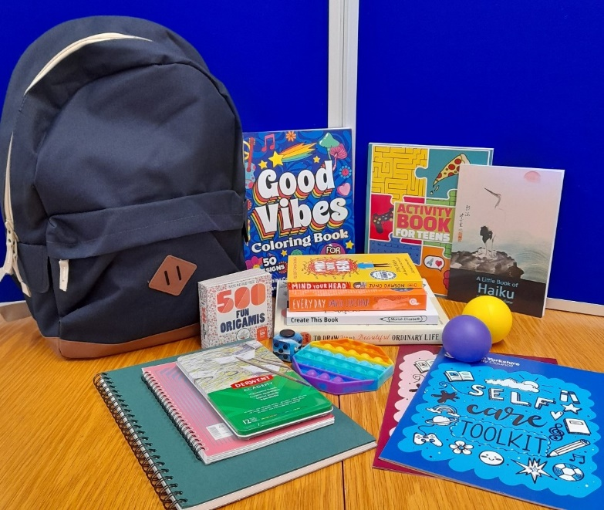

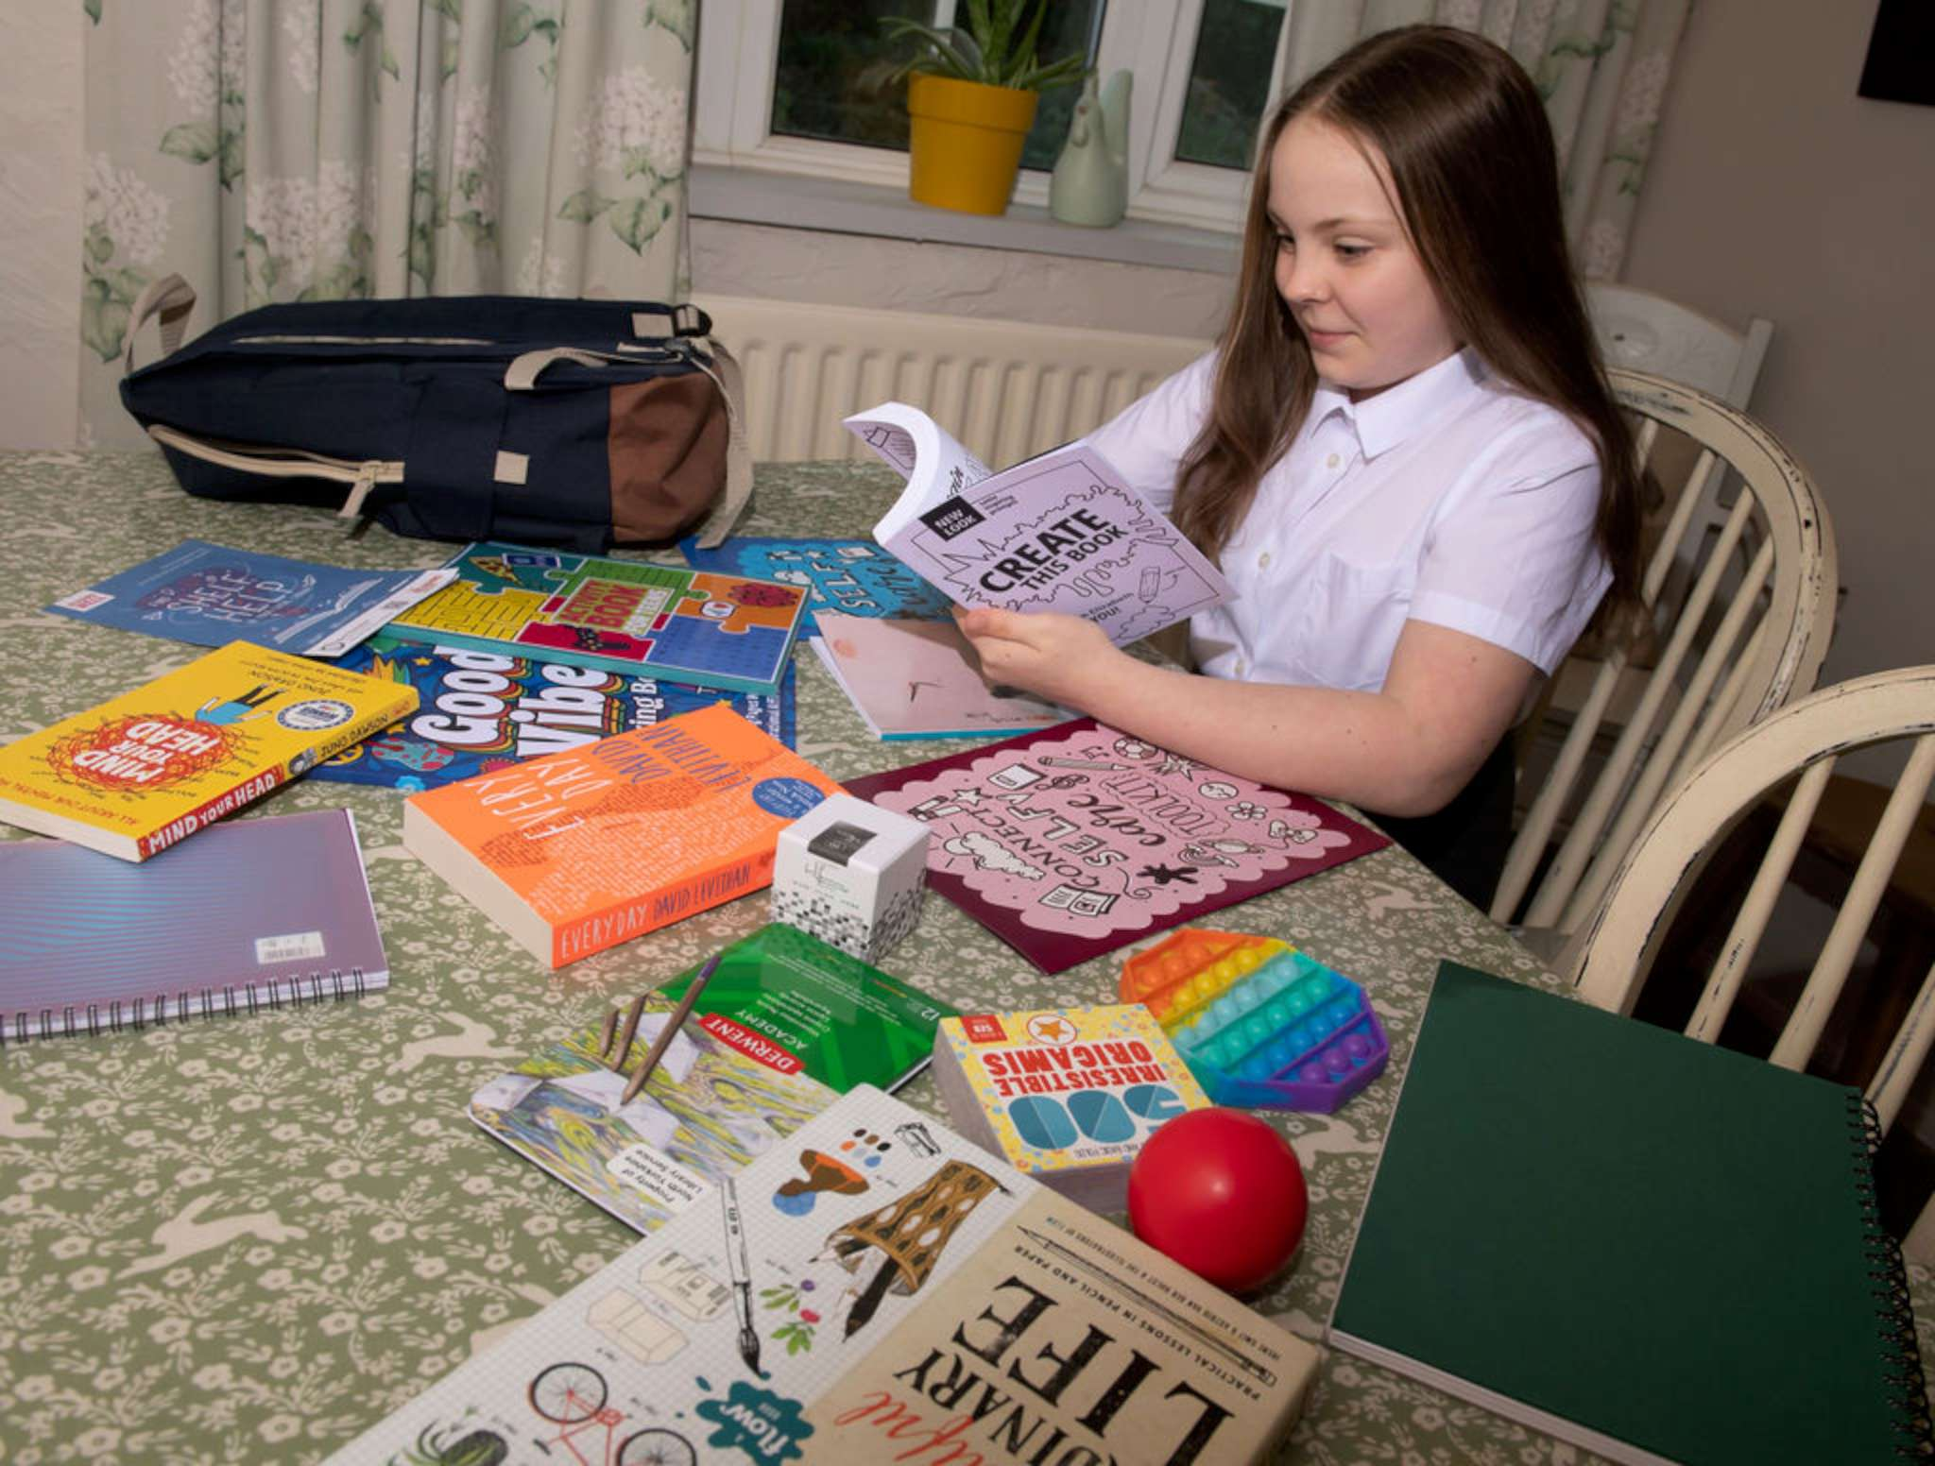

Your application may be chosen to be uploaded to the “best practice” page of the Self Care Forum website to share excellence so that others might use the learnings in your application to empower more people. We will also include your email address so that people may get in touch with you. If you would prefer that your application and/or email address was NOT chosen then please make it clear in the box provided below.
We look forward to receiving your application. Please email your completed form to:
selfcare@selfcareforum.org

About the Self Care Forum
The Self Care Forum supports organisations in helping their communities and service users better understand how to self care. It is the leading independent provider of best practice around self care and the ‘go-to’ place for top quality resources, current opinion, and self care interventions in the UK.
It is a charity and aims to improve public health by promoting self care at national policy level. It creates resources, runs the UK-wide National Self Care Week, and supports robust research evidence.

For more information about the Self Care Forum please go to the website. www.selfcareforum.org.

