Self Care Forum Self Care Innovations Award 2022

Award Application Form and Eligibility

The Self Care Forum is inviting applications of good practice and innovations in self care, personalised care, and social prescribing that have made a difference to individuals, groups, or organisations.

Who can apply?
This invitation is open to everyone, whether you are an individual, a community champion, an employer, GP practice, Local Authority, school, college, business, or services organisation (public, private, or charitable). For a guide, see examples table below.

£500 bursary
The winner will receive a £500 bursary to spend on a self care related initiative and the top entries will be included on the Self Care Forum website to share best self care practice and excellence. The winners will be announced during the UK’s National Self Care Week (12 – 18 November) as part of its launch and promotional activity.

Closing date for admissions: 31st July 2022.

Examples of possible initiatives | If specific health-related conditions were targeted, they might include
- 2021’s Self Care Week activities  - Coronavirus related self care  - Signposting to services  - Protecting mental health and wellbeing  - Promoting self care to the shielded population  - Self care for the elderly or other specific groups  - Self care introduced by employers  - Local authority population or community initiatives  - Pharmacy initiatives  - GP initiatives  - Self care education by schools, universities, or community groups such as Scouts, Guides etc  - Empowering vulnerable groups | - Long-term conditions  - Obesity  - Diabetes  - General health  - Nutrition  - Exercise  - Mental Health  - Self-treatable conditions/minor illness

Please use the form below to tell us about your self care initiative.
If you are typing directly into the form, do not worry if the box extends beyond the page – it will continue onto the next one.

Title and contact details.
Title of Initiative

‘uTime’ Staff Wellbeing Initiative

Name of Organisation and Region (please state context, ie general practice, community care etc)

Help and Care charity, Dorset. (Contracted by the Dorset Integrated Care System- formerly CCG- to provide community and surgery-based Social Prescribing Teams across the 18 Primary Care Networks in Dorset).

Name of person/team/individual being nominated

We are nominating the Dorset Self-management service team within Help and Care, where uTime started. This service aims to support people with long-term health conditions, and carers, to feel more confident self-managing on a day-to-day basis by providing tailored coaching sessions, connecting people to their community and working with them in partnership to access the right services.

Contact name for entry
Chloe Muir
Contact email for entry
Chloe.muir@helpandcare.org.uk
Timeframe and dates of initiative
- Project team set up and planning phase: July-September 2021.
- Pilot implementation October 2021- September 2022.
- Interim review and evaluation: April 2022.
- Final review and proposals to senior management about next steps –by October 2022.
Date of submission
29/07/2022

Problem(s) and how you tackled them.
What was the problem you were trying to tackle? (max 200 words)

Dorset Self-management team comprises around 60 link workers, care co-ordinators, social prescribers and health coaches (home or surgery-based). The team spends their working days supporting individuals with moderate to severe health, welfare or emotional needs, referred by the NHS or community groups.
Colleagues were often working in isolation and not everyone had access to reflective practice to offload client issues. The cracks began to show in colleagues’ physical and mental health, with stress and burnout being cited as reasons for staff illness. ‘You can’t pour from an empty cup’ is the saying and without our team at full strength it was severely affecting the number of clients we could help.
We were conscious that many of us were neglecting our own wellbeing, were still feeling disconnected from one another and found it difficult to ‘switch off’ from work and clients, as we were still mainly home-based.

One of the senior managers agreed that for many, work was about belonging and connections, and invited staff to brainstorm ideas to tackle the deteriorating staff morale. From this brainstorm came the idea of uTime and a small team of colleagues met to plan how it could work in practice to tackle the issue.
Please give a brief description of your self care innovation (max 250 words)

This small team was trusted by senior managers to develop the concept of uTime and plan a pilot.

So, what is uTime? Each member of staff (full and part-time) was granted two hours/month for activities to enhance their own personal wellbeing. This was to be labelled ‘uTime’. For ‘time-poor’ staff, we wanted this to feel like a guilt-free treat!
To begin with, the uTime team suggested activities for staff to take part in or invited staff to simply take uTime during the month to do a wellbeing activity of their choice, or even meet for a coffee with a colleague, when restrictions eased.
Almost immediately we realised what a plethora of skills and knowledge lay within the team, as many of our colleagues offered to run online activities to inspire staff to try something new. This included:
- Yoga nidra
- HIIT training sessions
- Foodie Friday healthy recipe videos
- Birdwatching videos
- Menopause café
- Wellbeing walks (face to face)
- A book group

As momentum grew and more staff engaged with the uTime concept we compiled and sent out a monthly newsletter, packed with ideas, such as recipes, app, book and music recommendations, seasonal nature photos taken on uTime activities and uplifting staff contributions about what promotes their wellbeing. We even have our own poet who contributes to the newsletter and she always raises a smile.
By popular request, there is now a closed Facebook group where colleagues post what they have spent their uTime doing too and share ideas and positive news.

What challenges or barriers were you faced with and how did you solve the problems or overcome the barriers? (max 250 words)

- Leadership Team approval
We already had some management support, but it was a considerable organisational commitment to grant 60 staff permission to take two hours out of their monthly working time. We presented our proposal to the Leadership Team, discussed the pros and cons of uTime and agreed to a 12-month trial period with staff logging their uTime on the calendar and if/how it was positively impacting their wellbeing. There was also the opportunity to share uTime ideas and anecdotes visibly on a TEAMS chat thread especially set up for initiative.
As part of the pilot, we would run an interim evaluation survey to gauge what staff thought of uTime and if it was having a positive impact.

Results were good- we have two months left of our pilot.

- Staff engagement
Some staff commented that they wouldn’t be able to use uTime as they’d feel guilty; their workload was too heavy, and they didn’t want to let clients wait longer for an appointment. There was also the issue of people forgetting to take the time as it was a new event to schedule into their calendar.
Our response to this was twofold:
- We invited the team managers to include uTime in monthly supervision meetings with staff, to help manage any scheduling conflicts and promote the benefits of self-care
- to communicate with staff via a range of media, as a reminder. This led to the monthly uTime newsletter being emailed to staff and a closed Facebook group being created.

Did you collaborate with other partners or organisations, if so, who were they?

Parks In Mind is a charity, who we often promote to staff and attend their events, as they run many local and online wellbeing events.

Simply Health- (our HR health partner). We gave a reminder to staff that we all have this health care package available to us.

Impact and outcomes
Who was the initiative directed at and what were the benefits to the targeted group or individuals? (max 250 words)

uTime was aimed at the 60 Self-Management team members and after six months of the pilot we ran an evaluation survey. Here are some benefits our colleagues mentioned:

- Better sleep - racing mind felt calmer
- Starting or rediscovering a hobby,e.g. drawing, baking
- Feeling fitter ‘knowing other colleagues were doing the workout too was a good motivator and re-energised me’.
- ‘Feeling of staff togetherness’ hearing about other people’s uTime
- Feeling looked after by their employer. ‘Fabulous to have that time during a working month to take a relaxed break. It is rejuvenating and greatly appreciated’.
- More confident about menopause symptoms. ‘I have learned so much and feel confident to talk to my GP about my symptoms now (as thought they were too mild to bother the GP about before). Having someone who is passionate and informative running the sessions, has been fantastic and I am grateful to have had this available’.
- Time to volunteer for litter pick by the sea
- More resilient in the face of a complex caseload. ‘If we feel supported and happy with our own wellbeing, then we are much more able to support the vulnerable people that we do, both emotionally and confidently’.
- Feeling gratitude and pride to belong to an organisation which values its staff
- Better work/life balance. ‘It has allowed me breathing space and rare time to myself. Between college, work and looking after my children I have no time for myself. Utime has given me 2 hours a month where I can be me’.

Were there further benefits to you, your colleagues, your organisation or to a wider area such as the NHS? If so, what were they? (e.g improved job satisfaction, smoother running of facility, happier service users, better use of scarce resources, cost saving)

- Menopause has often been a taboo subject and there are many colleagues in the team, who are at this stage of life (and many clients who were also battling with menopausal symptoms). One of our colleagues is very knowledgeable in this area and set up a ‘uTime Meno Café’ for staff to come and ‘Share & Learn’, knowing they would be supported and listened to. This boosted their confidence and wellbeing, but some unexpected bonuses arose too. Having developed knowledge and confidence from attending the uTime Meno café several staff are now setting up meno cafes either in the local community or in the GP surgery, where they are based. In this way, many more women will also find peer support and become better informed, as it is now recognised as one of the top five health issues for women. Additionally, some of our male colleagues attended to better understand how they could deal with clients (and partners) who were experiencing menopausal symptoms.

- Those in the pilot study commented that they felt their employer understood they had a stressful job and were wanting to look after their staff, which has increased staff morale. It has also led to staff skill-sharing and allowed some staff a chance to be more confident in their presenting skills, which in some cases has led to them offering their skills in a wider, community setting.

- Longer term it can be an attractive prospect for potential staff and we are waiting to see if it will impact staff sickness and turnover figures, both of which had risen sharply during the pandemic.

- This quote from Des Persse, our Director of Services relays his view of the wider benefits: ‘Practically, what I witnessed through the activities, the newsletters and the chat, was the development of a community – a very powerful one in terms of trust, support and ambition for everyone within it. As a senior manager, my pride comes from the recognition that we created the conditions for people to flourish through the innate sense of permission in our culture’.

Evidence
Please quantify the benefits of your initiative. (e.g. cost improvement, numbers of people helped, time saved)

Here is how Karen Wilmshurst, Self-Management team Operations Manager has quantified the benefits:

‘In the first six-month period of the uTime pilot, the Dorset Self-Management service received over 1700 referrals. We pride ourselves on contacting referrals within a few days and not having a waiting list. This can put the team under time pressure.

The team consists of around 60 staff. Every member of the team works with clients who are experiencing complex life challenges that affect them physically and mentally.
The diversity of the successes clients report include; getting grants for carers, helping people getting re-housed and coaching people through bereavement, anxiety or a new long term health diagnosis. Sometimes our clients have been passed around ‘the system’ before they arrive at our door, so these results are testament to the dedication and person-centred work that our team foster.

It is therefore vitally important that there is support for staff wellbeing through initiatives such as uTime. The opportunity to ‘de-clutter’ the brain is vital to maintain emotional resilience and uTime offers a range of activities and ideas to do just that.

uTime was set up and is coordinated by the staff themselves and alongside a number of online ‘live’ activities, there is a regular newsletter and Facebook page to help people stay connected and share how they are maintaining their health and wellbeing. The initiative is well utilised by the team and I fully endorse it along with this application’

Karen Wilmshurst, Dorset Self Management Team Operations Manager.

Des Persse, Director of Services added:

‘The conversation regarding employee wellbeing & mental health accelerated during the pandemic. Rightly, organisations are expected to be proactive in understanding workforce wellbeing and ideally, coproduce a wellness strategy with staff that will foster a culture where everyone feels safe and secure in the knowledge, the employer ‘has their back’ when it comes to physical and mental health. At Help & Care, it is in the DNA of the company to ask people and communities what they want, need and desire as opposed to telling them! This translates to our workforce too – individuals and teams knew instinctively they had permission to do what they needed, to thrive and support one another during the challenges of the pandemic.

The uTime programme would never have worked had it been a “top down” initiative. But understanding that our people are instinctively caring in their work and want to operate within a caring framework: we fully trusted the benefit of a staff-informed framework, with a peer led philosophy creating bespoke healthy activities and interactions. This sense of community and support that has generated organically, is priceless’.

Do you have formal or anecdotal evidence of success? (e.g. qualitative, quantitative, informal feedback?)
A survey was undertaken after six months of the pilot to ascertain the effectiveness of the initiative. The survey concluded that 76% of respondents use uTime. The following quotes came from the survey.

‘I have attended a webinar on how to improve your sleep, as this is a big issue for me, and I have incorporated some of the ideas which have helped’

‘ I have used one session to kick-start my aerobics exercise sessions at home - I have cancelled my gym membership to save some money, so needed to find something else I could enjoy to keep fit and de-stress - and this has been great’

‘I really enjoy using my uTime, although at the beginning I felt very guilty taking “time out for me” during my working day!’

‘I have enjoyed finishing work at 3pm one day and going for a swim which I really enjoyed. I think the opportunity to have this special time for our own wellbeing once a month is a very kind gesture of Help and Care and shows the appreciation of the emotional and complex work we do supporting others’.

‘Definitely beneficial. A chance to clear the head and do some physical activity to get away from phones/screens’.

‘It has made me feel appreciated in the job I do, being able to get back a bit of time for me to refresh and recharge’.

‘The 2 hours per month are something I look forward to, as a much needed break from work to recharge my batteries, especially when dealing with some complex and very sad cases’.

‘Newsletter is lovely and uplifting. Has made me think about trying things that I hadn't considered before’.

‘I have also enjoyed attending some of Nigel's Yoga Nidra sessions, from which I have found it helpful to learn some new relaxing breathing techniques’.

‘I would like to say my appreciation for the colleagues in the uTime team, in having a working career of 44 years I have never had anything like this and wished that it had been offered by other organisations I’ve worked for. I believe it leads to the enrichment of the work force and shows the commitment of the management to the well-being of their staff’.

…and one more quote from a brand new member of staff:
‘When I found out about uTime after recently joining Help & Care, I was really impressed! Giving us time to do something for ourselves whether that be an exercise class or an extra break in our day to go for a walk, shows that Help & Care practise what they preach. I'm proud to say I work for a company that puts not just our clients’ health and wellbeing first but also their staff’.
What was the cost of this initiative in terms of time, money, and/or other resources? Please be as specific as you can

Cost of each staff member taking off two hours working time per month. No external costs.

And, finally…
Are there any lessons you learned or top tips that you would like to share? (max 200 words)
- Managers
Whilst we had early support from one senior manager, we (the staff-led uTime project team) were overzealous in our desire to get uTime started, without ensuring we had fully explained the concept to the Help & Care Leadership team. This led to initial resistance until we presented the idea, together with our commitment to monitor and evaluate the pilot. Their support (as quotes show) has since been 100% behind us.
TOP TIP: Don’t assume others realise how great your idea is before they have been given the chance to see a practical implementation plan!

- Staff
Not all frontline staff engaged initially, despite launching ‘uTime’ at a Team meeting. We wanted to know why some weren’t accessing this privilege to support their wellbeing. Through the interim survey we learnt that our caring colleagues felt guilty and couldn’t believe the Senior Leadership team would agree to putting such emphasis on staff self-care. We tackled this through regular staff email reminders about uTime and even getting Des (Director of Services) to write a piece in our newsletter about his uTime.
TOP TIP: Expect new, innovative projects to start slowly and build momentum, especially as staff join and it’s ‘the norm’ for them.

Did you use any of the Self Care Forum’s resources? If so, please specify.

We often use the fact sheets with our clients (if appropriate), especially the Self-Care POWER of Self-Care. We now also reference this on our training for our new staff and it fits very well with the uTime ethos, as we use the ‘Five Ways to Wellbeing’ model with many of our clients. Our uTime Menopause Café leader also uses the Menopause fact sheet as part of her resources to share with participants.

Please state your social media addresses including all those who were involved in the initiative.

We have created a Help and Care uTime private Facebook group for staff to share how their use their time and post ideas and motivation. Other social media (e.g. MS Team channels) are internal.

https://www.facebook.com/groups/623170455565263

Why do you think this initiative deserves to win the award? (Max 100 words)

uTime is a simple idea- allow overwhelmed, ‘time-poor’ staff to plan time for self-care so they will have more resilience to help others and can inspire clients to follow their lead. Self-care could help many people with long term health conditions, but it’s deemed by many as a luxury item. Modern society often praises ‘busyness’ not ‘wellbeing;’ this initiative starts to redress this unhelpful balance across our Dorset-wide client base too.
If we win the award we would use the money to offer staff subscriptions to Headspace or other wellbeing resources to allow them to continue to prioritise self-care.

Do you have an image, materials or weblinks to supplement your application? Please supply no more than 2 images which may also be used to promote your application if successful.

This was the first newsletter from October 2021.
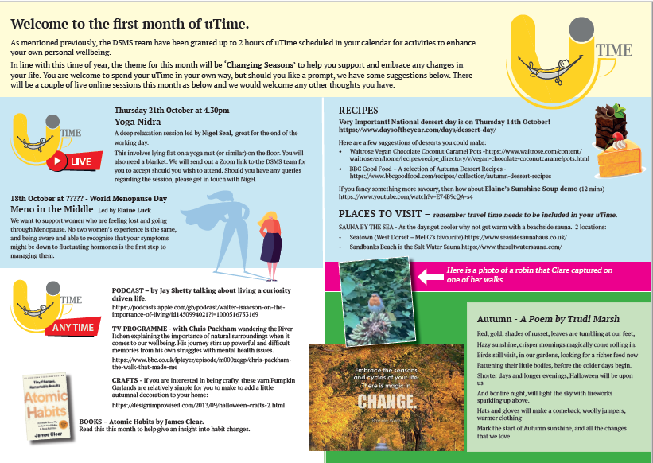

This is a thumbnail version of our Summer 2022 newsletter. It has grown to six pages, largely due to staff sending in contributions and offering to run ‘live’ events for colleagues.

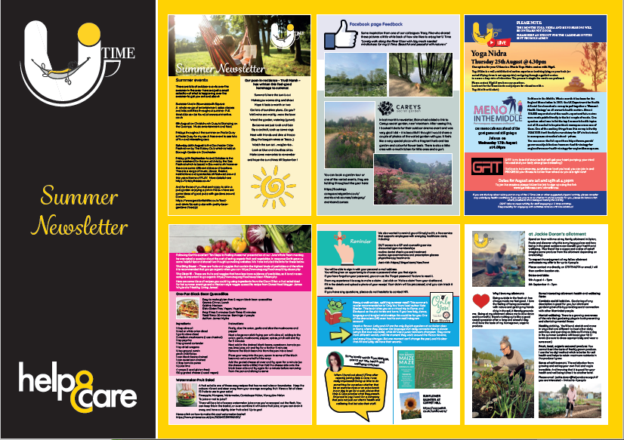
Your application may be chosen to be uploaded to the ‘best practice’ page of the Self Care Forum website to share excellence so that others might use the learnings in your application to empower more people. We will also include your email address so that people may get in touch with you. If you would prefer that your application and/or email address was NOT chosen then please make it clear in the box provided below.
Yes that is fine.
We look forward to receiving your application. Please email your completed form to:
selfcare@selfcareforum.org

About the Self Care Forum
The Self Care Forum supports organisations in helping their communities and service users better understand how to self care. It is the leading independent provider of best practice around self care and the ‘go-to’ place for top quality resources, current opinion, and self care interventions in the UK.
It is a charity and aims to improve public health by promoting self care at national policy level. It creates resources, runs the UK-wide National Self Care Week, and supports robust research evidence.

For more information about the Self Care Forum please go to the website. www.selfcareforum.org.

