Self Care Forum Self Care Innovations Award 2022

Award Application Form and Eligibility

The Self Care Forum is inviting applications of good practice and innovations in self care, personalised care, and social prescribing that have made a difference to individuals, groups, or organisations.

Who can apply?
This invitation is open to everyone, whether you are an individual, a community champion, an employer, GP practice, Local Authority, school, college, business, or services organisation (public, private, or charitable). For a guide, see examples table below.

£500 bursary
The winner will receive a £500 bursary to spend on a self care related initiative and the top entries will be included on the Self Care Forum website to share best self care practice and excellence. The winners will be announced during the UK’s National Self Care Week (12 – 18 November) as part of its launch and promotional activity.

Closing date for admissions: 31st July 2022.

Examples of possible initiatives | If specific health-related conditions were targeted, they might include
- 2021’s Self Care Week activities  - Coronavirus related self care  - Signposting to services  - Protecting mental health and wellbeing  - Promoting self care to the shielded population  - Self care for the elderly or other specific groups  - Self care introduced by employers  - Local authority population or community initiatives  - Pharmacy initiatives  - GP initiatives  - Self care education by schools, universities, or community groups such as Scouts, Guides etc  - Empowering vulnerable groups | - Long-term conditions  - Obesity  - Diabetes  - General health  - Nutrition  - Exercise  - Mental Health  - Self-treatable conditions/minor illness

Please use the form below to tell us about your self care initiative.
If you are typing directly into the form, do not worry if the box extends beyond the page – it will continue onto the next one.

Title and contact details.
THE POWER OF SELF-CARE
…The NHS and beyond

Cirencester based Patient Participation Groups (PPGs)
Cirencester based Patient Participation Groups (PPGs)
Chris Smith
chris.smith1945@gmail.com
Cirencester Market Place – Tuesday 14th June 2022 10am – 4pm
30th July 2022

Problem(s) and how you tackled them.
The primary aims of the event are to engage, educate and empower individuals to
understand their overall health and mental wellbeing in an holistic way and to encourage a
Self-care approach to make positive lifestyle choices which empowers and develops more
healthy lifestyles.

OBJECTIVES
* To introduce Self-care consultations to empower people to take care of their own health and
mental wellbeing.
* To empower people to change lifestyle choices that impact on health, eg blood pressure,
weight, smoking and alcohol.
* To help people with diabetes understand healthy nutrition and manage their health.
* To signpost services supporting Self-Management.
* To engage people in a fitness regime.
* To introduce the Social Prescribing Scheme, and Link Workers.
* To promote the use of Self Care Forum Factsheets, enabling Self-care for common minor
illnesses.
* To raise the profile of Patient Participation Groups (PPGs) and further develop their role as advocates for the NHS and its services in our community.
* To ease pressures on the frontline NHS treatment services in the post covid pandemic situation

The innovation involved was multi-faceted:
- This was the first time that an open air Self-care event of this magnitude and diversity had been held certainly in this location, likely in the county and probably in England.
- The event was organised with the close cooperation of a joint working group of the Cirencester based PPGs: Phoenix Health Group, Cirencester Health Group, Upper Thames Medical Group and Rendcomb Surgery.
- Over 30 Self-care participants were present including NHS organisations, charities, several commercial organisations, supported by some healthy eating concessions and a local radio station.
- Many of the participants at the event used the opportunity to network with one another.
- The PPG presence was used not only to promote the work of these groups, but also to stimulate patients to join such groups.
- Funding for the event was obtained primarily from the Health groups themselves, together with certain other local organisations.
- Heartwize arranged for a group of senior school children to attend the event to be trained in CPR techniques and gave them demonstrations of the use of Automated External Defibrillators. As a direct result this, a second school in Gloucestershire have now also signed up for the Heartwize experience. The longer term view is that we will have a local team to be built around Gloucestershire schools, creating a generation of young lifesavers.

- Cooperation between the PPGs

A Joint Working Group was formed at the start with 6 members as “Directors” and the Chairmen of the two largest PPGs making ultimate decisions. The group worked in an exceptionally collaborative fashion.

- Funding requirements
It was clear that over £1,000 would be required to stage the event. This was raised at an early stage

- The terms under which The Cirencester Town Council operates markets required both the organiser and all participants to obtain appropriate Public Liability Insurance and produce acceptable Risk Assessments. As organisers the PPGs were responsible for ensuring this took place.

As both an organiser and a participant we arranged insurance and carried out our risk assessments. Two members of the Working Group liaised with the participants ensuring they provided us with appropriate information.

- Promotion

Together with Cirencester Town Council (who shared the costs) a quarter page advert was placed in the Ciren Scene including the distribution of 13,000 A5 flyers in their May edition, followed by a half page advert in the June edition. 2,000 additional flyers were distributed widely by the members of the PPG Joint Working Group.

- Social / mainstream media

Interviews were carried out by Gloucester Radio prior to and on the day.

Corinium Radio broadcast live at the event, throughout the day conducting a variety of interviews with both participants and the general public.

Wilts and Gloucestershire Standard covered the event online with supporting photographs.

In addition to the cooperation between the Cirencester based PPGs together with the Phoenix Charitable Trust in organising the event, collaboration with Cirencester Town Council and Cotswold District Council was also successful.

The 30 participants who we collaborated with in staging the event fell into 3 categories:

- Health and Wellbeing (including The NHS Information Bus provided by The Gloucestershire Clinical Commissioning Group (CCG);
- Mental Health and;
- The Community.
They were:
The Gloucester Rural Community Council - Community Well-being Service
Gloucestershire Health & Care NHS self-management
Gloucestershire Healthy Lifestyles

Slimming World
Alcoholics Anonymous
Al-Anon
The Big Yellow Bus Project
Change Grow Live
Everyone Active
Young Gloucestershire
Maggie's Cheltenham

Cancer Care Map

Independence Trust
Samaritans (non attendance re covid)

Rethink Mental Illness
Mental Health Experience Led Opportunities - Gloucestershire
Citizens Advice Bureau
Gloucestershire Domestic Abuse Support
Gloucestershire Parent Carer Forum (non attendance – literature displayed)

Gloucestershire Young Carers
Gloucestershire Carers Hub
The Self Care Forum (Factsheets)
Gloucestershire Health & Care NHS Foundation Trust -_ Partnership & Inclusion
Cirencester Physiotherapy Centre
Cirencester Eating Disorders Support group
Nutrition support
Dietary support

Gloucestershire Health & Care NHS Foundation Trust - Falls Assessment and Education Servic
Xyla Health and Wellbeing
NHS Diabetes Prevention Programme
Corinium Radio
Gloucestershire Fostering
The Rotary Club

Heartwize

Snap Fitness

Hobby Craft

Burgerlish Catering

Dexter’s Mobile café

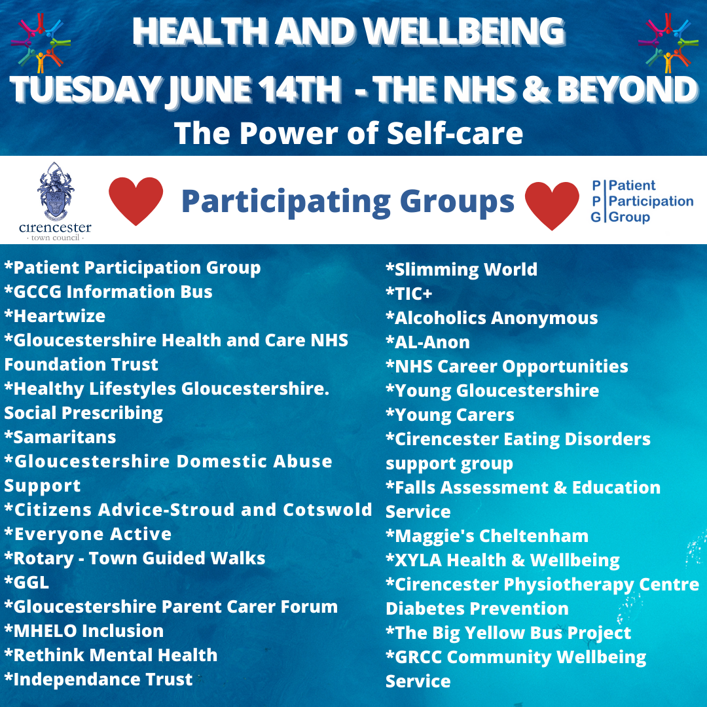
The following is a partially abbreviated list of the above participants used on the day.

Impact and outcomes
The event was primarily directed at the South Cotswolds local community residents, although some visitors from further afield in Gloucestershire and beyond were also welcomed. We are delighted to hear that several thousand people attended the event and there’s no doubt that, from our experience, a great many attendees gained the sort of support on the day we had hoped for.

Of course, the benefits to individuals and targeted groups are too diverse to detail simply because of the sheer number and diversity of the Self-care participants providing information and services. In this context, over 30 such groups were on hand to deliver a range of advice and guidance covering both general and specific interest within their specialty.

We were therefore delighted to secure a range of positive specific and general responses to the feedback survey on the day which is invaluable in enabling us to build on for future similar events. That feedback is detailed in subsequent sections.

The participants themselves benefitted by networking amongst themselves on the day and discovering and finding out about other resources which are available in the Self-care sector.

It is likely that the NHS locally benefitted indirectly by individuals seeking and receiving advice and possibly even preliminary diagnosis (eg re Diabetes, Blood Pressure and BMI testing. This will have saved resources within the NHS both with regards to GP and Hospital services.

The Patient Participation Groups who organised the event benefitted not only from the level of co-operation required amongst themselves but also by meeting and discovering in more detail the wide range of Self-care facilities being provided by the participants.

Both Cirencester Town Council and Cotswold District Council benefitted by experiencing exposure to and interaction with a large number of Self-care organisations with whom they will likely become further involved with in the future.

Evidence
As mentioned previously several thousand visitors from the local community attended the event to learn of the advice and guidance on offer. The invaluable advice gleaned will have informed family, friends and, via social media, of the many Self-care participants able to provide invaluable advice across a huge spectrum of healthcare. The resulting multiplier effect will help to spread the word in reaching many more thousands in need of help.

Some individual participant examples are as follows:

The NHS (Information Bus) was undertaking blood pressure tests, finger prick diabetes tests and BMI measurements. The potential benefits to those undertaking these services will have varied from reassurance through to early assessments of the need to take further action or seek additional medical assistance.

The Heartwize team trained 120 individuals during the day. This included a number of senior school children from Farmor’s School. This charity’s award-winning programme aims to increase public awareness of the problem of out-of-hospital cardiac arrest to ensure that basic resuscitation skills are taught in schools. Furthermore, its objective is to improve provision and awareness of Automated External Defibrillators (AEDs) in the community. By providing support and training in basic resuscitation skills, they hope to ensure that everyone knows how to recognise and respond to a cardiac arrest. This will increase the chance of survival for those affected and could save thousands of lives every year. On a national level, to date, they have trained over 40,000 individuals. This charity’s work is also increasingly important following the Government’s recent announcement that all state schools in England are to be provided with defibrillators by next summer.

The Cirencester Physio Centre was particularly popular with free injury assessment and diagnosis. Q and A sessions were run throughout the day to help people who had been struggling with stubborn injuries. They apply hands-on therapy as a way of completely stopping pain, and place as much importance, if not more, on education and exercise so that once they have the pain under control with this new knowledge individuals can manage and prevent their symptoms returning.

A feedback form was sent to all participants and a response rate of over a third was achieved with the responses indicating the following:

- 91.7% agreed strongly or agreed that the event was beneficial to their organisation
- On a 5 point scale 66.7% ranked the level of footfall and engagement to be in the top 2 levels
- Networking on a similar basis came in at 75%
- 100% indicated they were interested in joining a future event and 50% indicated that they would be prepared to assist in its organisation by joining a working group

Certain specific responses to the survey included the following:

- Over 140 people were given a diabetes test
- Engaged with over 100 members of the public
- Engaged with over 72 people
- Talked with 70 people
- Spoke to over 30 people about cancer

Following the event two Cirencester Business and Community awards have been received relating to the event, one for an individual’s significant contribution of the year and the second for the community project of the year.

In addition, the Market place organiser, Cirencester Town Council, have indicated that they would certainly consider and would hope to repeat such an event in future years.

Participants have also requested a repeat event with some wanting to make reservations now with suggestions for additional activities to involve the community.

The Cotswold District Council have also indicated their willingness to further participate and possibly contribute funding to future such events.

Several GPs from the local surgeries visited the event and informed us (the PPGs) that they were very impressed.

Costs to date amounted to £1,120

Individual PPG members provided various furniture gazebos and other items in support of the event day from their personal resources. It is estimated that these and other contributions of services materials etc amounted in total to the equivalent of approximately £3,000.

The Cirencester Town Council shared promotional costs amounting to almost £300. They also helped significantly by two members of staff who attending probably 15/20 or more planning meetings of over 2 hours each prior to the event.

One of the Working Group we estimate spent at least 50 % of her time working on the project for around 6 months leading up to the event having prior to this time spent at least an equivalent amount of time over the previous year in investigating a variety of different venues and topics for such an event. The others (5) we estimate possibly spent 10 % of their time over this period of time. An additional resource level from other PPG members possibly accounted for between another 1 or 2 people at this 10% level.

And, finally…
Make sure you arrange any open-air event to take place on a gloriously sunny day as we did!

An effective Committee/Joint Working Group structure involving a comparatively small “permanent” membership with appointed leaders was most effective.

Regular meetings with formal minutes are essential.

Raise the necessary funding at the earliest opportunity particularly as commercial companies/organisations tend to set annual budgets for charitable etc donations.

Ensuring assistance from the venue providers is another must, as well as ascertaining any special or specific terms and conditions that might apply from them in providing the venue etc.

Extensive pre-event promotion is again essential.

Whilst we attempted to achieve media coverage of the event perhaps by devoting more resource in advance to this or co-opting a celebrity would have increased our coverage. Achievement of coverage is of course very dependent on other events on the day which are completely unpredictable.

We used a display of the Self Care Forum’s Factsheets and compiled a poster showing pictures and descriptions of all the Factsheets with a generic QR code directly linking to the appropriate web page together with individual QR codes linking to the 3 most popular Factsheets. Several of these A3 sized posters were displayed at the PPG gazebo.

YouTube video of the event (click image to play)
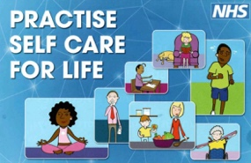

https://www.youtube.com/watch?v=CQUMscKfWcQ

facebook.com/CirencesterTC
twitter.com/CirenTC
Instagram.com/cirentc
https://twitter.com/cirenscene
https://www.facebook.com/CirenScene/
https://www.instagram.com/cirenscene/

Virtually every participant has social media accounts and to list them would likely involve over 100 addresses

An example is Gloucestershire Health and Care NHS Foundation Trust

https://www.facebook.com/GlosHealthNHS
https://twitter.com/GlosHealthNHS
https://www.linkedin.com/company/gloshealthnhs/
https://www.instagram.com/gloshealthnhs/
https://www.youtube.com/channel/UCc_glhgrkXz0lNZyWLoBPNQ

A further example Slimming World has the following:

https://www.facebook.com/slimmingworld/
https://twitter.com/SlimmingWorld
https://www.youtube.com/user/slimmingworld
https://www.instagram.com/slimmingworld/

and Cirencester Physio Centre:

https://www.facebook.com/cirencesterphysiocentre
https://www.instagram.com/cirencesterphysio/

This was the first time that a specific open air Self-care event had been held at this venue.

It involved a huge number of differing Self-care providers from the Public Charitable and Commercial sectors.

This was a first in the county (Gloucestershire) and just possibly in the UK

It attracted likely thousands of visitors from the local community many or most of whom will have benefitted from some or many of the Self-care services which were represented.

Potentially the Heartwize training and their future plans locally will lead to the saving of many lives

Image 1 – A5 flyer

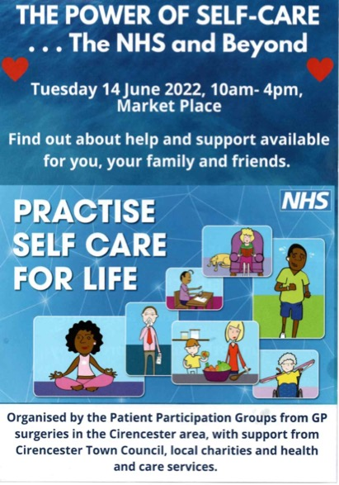

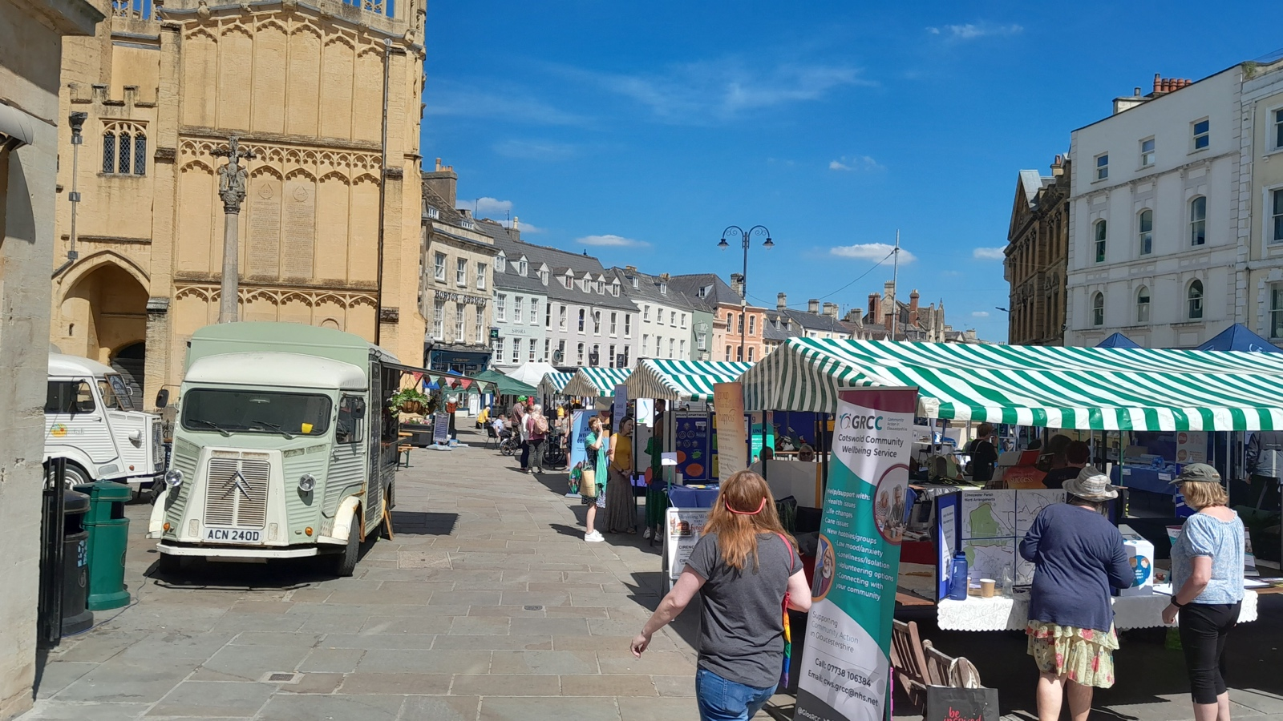
Image 2 – The Market Place on the day
Weblinks for the main organisers and participants

https://www.phoenixhealthgroup-cirencester.co.uk/practice-information/patient-participation-group/

https://cirencesterhealthgroup.co.uk/practice-information/patient-participation-group/

https://cirencester.gov.uk/markets

https://www.cotswold.gov.uk/

https://www.gloucestershireccg.nhs.uk/about-you/your-views/nhs-information-bus/

https://www.ghc.nhs.uk/our-teams-and-services/self-management/

https://www.hlsglos.org/

https://www.slimmingworld.co.uk/

https://www.alcoholics-anonymous.org.uk/

https://www.al-anonuk.org.uk/

https://www.bigyellowbusproject.co.uk/

https://www.changegrowlive.org/

https://www.everyoneactive.com/centre/cotswold-leisure-cirencester/

https://www.youngglos.org.uk/

https://targetovariancancer.org.uk/support-for-you/events/local-groups/maggies-centre-cheltenham

https://www.cancercaremap.org

https://www.independencetrust.co.uk/

https://www.rethink.org

https://www.yourewelcomeglos.org/users/mhelo

https://www.citizensadvice-stroudandcotswold.org.uk/

https://www.gdass.org.uk/

https://glosparentcarerforum.org.uk/

https://www.glosyoungcarers.org.uk/

https://www.carersuk.org/help-and-advice/get-support/local-support/gloucestershire-carers-hub

https://www.selfcareforum.org/

https://www.ghc.nhs.uk/

https://www.cirencesterphysiotherapycentre.co.uk/

https://www.bewellglos.org.uk/cirencester-eating-disorders-self-help-group/

https://www.ghc.nhs.uk/our-teams-and-services/falls/#:~:text=The%20Falls%20Assessment%20and%20Education,different%20locality%20across%20the%20county

https://xylahealthandwellbeing.com/

https://preventing-diabetes.co.uk/

https://coriniumradio.com/

https://www.gloucestershire.gov.uk/fostering/

https://www.rotary-ribi.org/clubs/homepage.php?ClubID=595

https://www.heartwize.org/

https://www.snapfitness.com/uk/gyms/cirencester/

https://www.hobbycraft.co.uk/stores/cirencester

https://www.instagram.com/burgerlish/

Your application may be chosen to be uploaded to the “best practice” page of the Self Care Forum website to share excellence so that others might use the learnings in your application to empower more people. We will also include your email address so that people may get in touch with you. If you would prefer that your application and/or email address was NOT chosen then please make it clear in the box provided below.
We look forward to receiving your application. Please email your completed form to:
selfcare@selfcareforum.org

About the Self Care Forum
The Self Care Forum supports organisations in helping their communities and service users better understand how to self care. It is the leading independent provider of best practice around self care and the ‘go-to’ place for top quality resources, current opinion, and self care interventions in the UK.
It is a charity and aims to improve public health by promoting self care at national policy level. It creates resources, runs the UK-wide National Self Care Week, and supports robust research evidence.

For more information about the Self Care Forum please go to the website. www.selfcareforum.org.

